**REFRIGERATOR CUM AIR CONDITIONER**

**PROJECT REPORT SUBMITTEDBY**

*VISHNU T M (ASI17ME114)*

*SANJU PETER (ASI17ME094)*

*SEBIN K DAVIS (ASI17ME096)*

*SREENIVASAN S (ASI17ME103)*

**Under the guidance of**

*SANDEEP O S*

*Asst. Professor – Mechanical Dept.*

***In partial fulfillment of the requirements***

***For the award of the degree of***

**BACHELOR OF TECHNOLOGY**

in

**MECHANICAL ENGINEERING**

**(NBA ACCREDITED)**







The APJ Abdul Kalam Technological University

Adi Shankara Institute of Engineering and Technology, Kalady

|  |  |
| --- | --- |
| |  | | --- | | **REFRIGERATOR CUM AIR CONDITIONER**  **PROJECT REPORT SUBMITTEDBY**  VISHNU T M (ASI17ME114)  SANJU PETER (ASI17ME1094)  SEBIN K DAVIS (ASI17ME096)  SREENIVASAN S(ASI17ME103)  **Under the guidance of**  SANDEEP O S  *Asst. Professor – Mechanical Dept.*  ***In partial fulfillment of the requirements***  ***For the award of the degree of***  **BACHELOR OF TECHNOLOGY**  in  **MECHANICAL ENGINEERING**  **(NBA ACCREDITED)**    The APJ Abdul Kalam Technological University  Adi Shankara Institute of Engineering and Technology, Kalady    *Certified that this is a bonafide record of the project entitled*  **“REFRIGERATOR CUM AIR CONDITIONER”**  *Submitted by*  VISHNU T M (ASI17ME114)  SANJU PETER (ASI17ME094)  SEBIN K DAVIS (ASI17ME096)  SREENIVASAN S (ASI17ME103)  *during the year 2020-2021 in partial fulfillment of the requirement for*  *the award of the degree of*  *Bachelor of Technology in Mechanical Engineering*  Internal Supervisor Head of the Department | |
|  |

**ACKNOWLEDGEMENT**

At the very outset I would like to give the first honors to God, who gave the wisdom and knowledge to complete this Project.

My extreme thanks to ***Dr. Suresh V***, Principal for providing the necessary facilities for the completion of this project in our college.

I sincerely extend my thanks to **Dr K T Subramanian**, HOD, Mechanical for all the help, motivation and guidance through the seminar.

I wish to extend my sincere thanks to all my Project coordinators **Ben Austin** and My Project Guide **Sandeep O S**, Department of Mechanical Engineering for their valuable guidance and support throughout the Project.

I wish to extend my sincere thanks to all Teaching and Non-Teaching faculty in the Department of Information Technology for their valuable guidance.

I also thank my Parents, Friends and all my well wishers who had supported directly and indirectly, during the course of the Project.

CONTENTS

|  |  |  |  |
| --- | --- | --- | --- |
| ***CHAPTER*** | | ***TITLE*** | ***PAGE NO.*** |
| Vision and Mission of the Department | | | 6 |
| Abstract | | | 7 |
| List of Figures | | | 8 |
| List of Abbreviations | | | 9 |
|  | | | |
| 1 | Introduction | | 10 |
| 2 | Literature Survey | | 12 |
| 3 | Objective | | 14 |
| 4 | Methodology | | 15 |
| 5 | Working Principle | | 16 |
| 6 | Design | | 19 |
| 7 | Working | | 20 |
| 8 | Components | | 22 |
| 9 | Material Selection | | 24 |
| 10 | Result and Discussion | | 25 |
| 11 | Future scope | | 27 |
| 12 | Conclusion | | 28 |
| References | | | 29 |

**VISION AND MISSION OF THE INSTITUTE AND DEPARTMENT**

**THE VISION OF ASIET**

|  |
| --- |
| To emerge as a centre of excellence in engineering, technology and management by imparting quality education, focussing on empowerment and innovation. |

**THE MISSION OF ASIET**

|  |
| --- |
| 1. To impart quality professional education for total upliftment of the society.  2. To create congenial academic ambience that kindles innovative thinking and research.  3.To mould competent professionals who are socially committed and responsible. |

**THE VISION OF DEPARTMENT OF MECHANICAL ENGINEERING**

|  |
| --- |
| “To make mechanical engineering programme a centre of excellence in professional education and research.” |

**THE MISSION OF DEPARTMENT OF MECHANICAL ENGINEERING**

|  |
| --- |
| 1. To provide quality education for moulding competent professionals in Mechanical Engineering.  2. To facilitate continual learning environment.  3. To promote collaborative activities and positive contributions to society. |

ABSTRRACT

Refrigerator cum Air conditioner is the combination of two units i.e. domestic Refrigerator and Air-Conditioner. Our aim is to develop a device that performs both task at same time i.e. cooling refrigeration cabin and room. By this method the energy and cost can be reduced from the cost of individual equipment. In minimum construction, maintenance and running cost, this attempt is quite useful for domestic purpose thus those who cannot afford an Air Conditioner can have the comfort of Air Conditioner. Refrigerator has become a necessity of all households in 21st Century. In all metropolitan cities, environment degradation due to automobile & other factors is on the rise, therefore the requirement of air-conditioner has already been felt. The motivation for the project comes from rising energy demands and hence its cost. As we all know that we are lacking of power resources, so this project will help us in tackling this problem as we are trying to make a personalized cooling system which will run at a very low cost that can be afforded by a common man. Another objective of this project is to improve the utilization of waste heat from a domestic refrigerator. The continual operation of this equipment accounts more electrical energy consumption. Furthermore, a significant amount of waste heat is rejected by the condenser of refrigerator. The heat rejected by condenser is of low quality, meaning temperature is low. Thus, practical uses of waste heat from the domestic refrigerators are typically limited to space heating and water heating.

List of Figures

|  |  |  |
| --- | --- | --- |
| **Figure** | **Name** | **Page No.** |
| 1 | % share of Indian population owning Refrigerator | 11 |
| 2 | Vapor Compression Refrigeration cycle | 18 |
| 3 | P-h diagram of VCRS | 18 |
| 4 | Model of Dual Evaporator system | 19 |
| 5 | Refrigeration cum Air Conditioner | 20 |
| 6 | Working of Refrigeration cum Air Conditioner | 21 |
| 7 | Fabricated Prototype | 25 |

List of Abbreviations

|  |  |
| --- | --- |
| **Abbreviation** | **Explanation** |
| AC | Air Conditioner |
| VCRS | Vapor Compression Refrigeration System |
| COP | Coefficient of Performance |
| HFC | Hydro Fluro Carbons |
| PRV | Pressure Regulating Valve |

1. INTRODUCTION

In nature heat transfer occurs from high temperature to lower temperature without requiring any external devices. The reverse process cannot occur by itself. So in order to make this happen devices called refrigerators are required. Refrigerators and air conditioners play a very important role in modern human life for cooling and heating requirements. It covers a wide range of application starting from preservation of food products to the thermal comfort to human beings by means of air conditioning and heads living standard of people. The utilization of refrigerators and air conditioners in homes hospitals offices vehicles and industries provides thermal comfort in living or working environment and hence plays an important role in increased industrial production of any country.

Need for Refrigerator

The powerful change potential embedded in the innocuous looking cold storage box nestled into virtually every kitchen in the world. the refrigerator is a taken-for-granted component of food practices. The refrigeration technology and its potentials for affecting home practices are spreading to kitchens in the Global South through increasingly liberal transnational markets. A research unearthed how the refrigerator’s powerful time saving and food preserving potentials are eroding deeply anchored ideas about diet and health in India. The infrastructural tentacles of refrigeration are taking root and bringing with them the same dramatic changes in food production, delivery and consumption that we have seen in the rich countries of the world. The energy and environmental consequences of these refrigerator-driven changes are briefly examined.

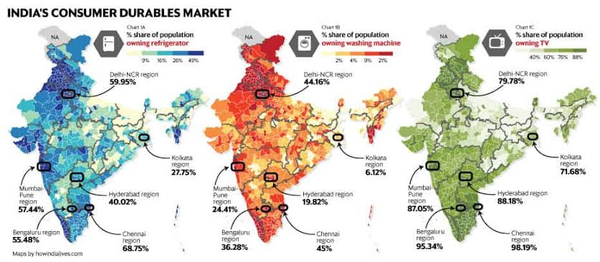

Figure 1

Need for Air Conditioner

Excessive heat or cold causes the body to expend energy in an attempt to maintain the proper internal temperature. Without air conditioning to control air temperature and humidity in your living or work space, humans use more energy, which might cause them to feel lethargic. Although technology for air conditioning had been invented in 1902, the share of Indians with air conditioning is still small, roughly 5 percent. Rising incomes are making air conditioners more attainable, while rising temperatures are making them a necessity. The increasing demand of energy primarily for refrigeration air condition and heat pump application is around 26 to 30 percentage which degrades the environment produces global warming and it depletes awesome layer. According to a study the total installed air conditioner capacity in India would increase threefold by 2030 which intern increases the demand for electricity which cause a huge impact to our environment.

**SCOPE OF WORK**

Therefore, to overcome these aspects, we are making a working model of Refrigerator cum Air conditioner by combining the two systems i.e., Domestic Refrigerator and Air conditioner into a combined system, which performs bothtask at same time i.e. cooling refrigeration cabin and surroundings such that the running cost becomes negligible and the power consumption will reduce. Because of its minimum construction and running cost, and portability this working model is quite useful for domestic purpose thus those who cannot afford an air conditioner can have the comfort of air conditioner. This is how we are trying to make the environment and a common man comfortable. By this product, a common man could have a sound sleep so that his productivity for the next day increases.

Refrigerator cum Air conditioner by combining the two systems i.e., Domestic Refrigerator and Air conditioner into a combined system, which performs bothtask at same time such that the running cost becomes negligible and the power consumption will reduce. When we compare the energy consumed by a Refrigerator cum air conditioner with the sum of energy consumed by a single air conditioner and refrigerator, our product would have consumed less energy.

This phenomenon has been utilized in the development of refrigerators which as we all know is a household equipment used to keep the vegetables fresh. Same system has been utilized to bring up the concept of air conditioning. If these systems are being used separately then operating and initial costs associated with both of these products is higher. Hence there have been several attempts worldwide to come up with a single setup where both of these systems may be employed so that the overall cost of the apparatus is reduced.

2. LITERATURE SURVEY

1.Design, Construction of Combined Air-conditioning and Refrigeration Unit

In a paper published by Mr. V.D.Navle, Prof.J.N.Yadav titled as "Design, Construction of Combined Air conditioning and Refrigeration Unit” in which by recovering part of energy for air conditioning effect energy can be saved. Since variation of outdoor air temperature is small in tropical countries, cooling is needed year round. This is the best condition to perform combined effect of refrigerator and air conditioners for energy saving. A

prototype combined air conditioning and refrigeration is designed and built. Refrigeration system using CO2 was commonly applied in marine sector. At that time, this machine was operated as subcritical cycle. There had been operating problem with this system when the ship was passing through hot water temperature where its cooling capacity drops rapidly (Lorentzen, 1995). To increase the cooling capacity, some additional CO2 had to be charged

into the system and then discharged when air temperature has decreased, which of course was not a good practice from operational practice point of view. This problem has been solved by the invention of Prof. Gustav Lorentzen who suggest transcritical cycle in place of subcritical cycle which make possible to operate the transcritical cycle like subcritical cycle without a need of charging and discharging CO2 manually.

2.Investigation of a Domestic Refrigerator Having Water-Cooled Condenser Using Various Compressor Oils

In one article by Sreejith k published journal papers on “Experimental Investigation of a Domestic Refrigerator Having Water-Cooled Condenser Using Various Compressor Oils” stating that condenser coils can be used for floor heater. Household refrigerator is common appliance that consists of thermally insulated compartment and which transfers heat from inside compartment to its external environment so that the condenser coil gets heated and can be used as a floor heater by simply forming a floor by adjusting the coil to the floor. So the floor heater can be used for heating water and many other purposes. S.C. Kaushik. presents an investigation of the feasibility of heat recovery from the condenser of a vapour compression refrigeration (VCR) system through a Canopus heat exchanger (CHE) between the compressor and condenser components. The presence of the CHE makes it possible to recover the superheat of the discharged vapour and utilize it for increasing the temperature of the external fluid (water) removing heat from the condenser. The effects of the operating temperatures in the condenser and evaporator for different inlet water temperatures and mass flow rates on the heat recovery output and its distribution over the condenser and CHE (the fraction of the condenser heat available through the CHE), available outlet water temperature and heat recovery factor have all been studied and optimum operating parameters for feasible heat recovery have been ascertained. The parametric results obtained for different working fluids, such as R-22, R-12, R717 and R-500, have been presented. It is found that, in general, a heat recovery factor of the order of 2.0 and 40% of condenser heat can be recovered through the Canopus heat exchanger for a typical set of operating conditions.

3.The Use of Natural Refrigerants

Lorentzen G published a paper on The Use of Natural Refrigerants: A Complete Solution To The CFC/HCFC Predicament, International Journal of Refrigeration on 1995.The ideal refrigeration or heat pump cycle for a given purpose is defined by the boundary conditions of the application and is completely independent of the refrigerant used. The real cycle should approach the theoretical ideal as closely as practically possible. The thermodynamic and heat transfer properties of the refrigerant are important in this respect. Natural substances such as ammonia, propane and carbon dioxide are often better than the present halocarbons in this regard. By using simple methods of safety, it is possible to use these three natural fluids for practically all conventional refrigeration and heat pump systems.

4.*Refrigerant* System for Vehicle Air-Conditioning, Phoenix Alternate Refrigerant Forum

At 1999 Furuya S. and Mathur G.D published a paper on A *CO2 Refrigerant* System for Vehicle Air-Conditioning, Phoenix Alternate Refrigerant Forum.

5.Feasilbility study and Development of Refrigerator cum Air Conditioner

***A. Prof. S. K. Gupta***reported a paper about the attempt he made to merge Domestic Refrigerator and Air conditioner into a combined system by which the power consumption will reduced, cost and space will be minimum. BECAUSE OF ITS MINIMUM construction, space and cost an ordinary man can afford it easily. After experimentation he conclude that a common man can have comfort of air conditioner at very low running cost or zero cost, which would prepare him for better productivity for the next day.

6.Investigation of the effect of HFC Refrigerant (134a) on VCRS

***B. M. Fande and A. M. Andhare***published a paper which is about the experimental investigation of the effect of HFC refrigerant R134a on a vapour compression refrigeration system by using two expansion devices with the conservation of energy by waste heat recovery system. He used two different evaporators for air-cooling and water chilling respectively and a water-cooled condenser is used to produce hot water. The existing system can be easily retrofitted as a waste heat recovery device and R134a can replace the existing R22 refrigerant with minor modifications.  After experimentation, the maximum temperature achieved in water tank with 50 litres of water is 45 C during 3 to 4 working hour. After that, performance of system decreases so it needs a regular use of that hot water which can be further used for household and industrial purposes.

3. OBJECTIVE

* To develop an optimized unit of Refrigeration cum Air Conditioner

We are making a working model of Refrigerator cum Air conditioner by combining the two systems i.e., Domestic Refrigerator and Air conditioner into a combined system, which performs bothtask at same time i.e. cooling refrigeration cabin and surroundings such that the running cost becomes negligible and the power consumption will reduce

* Replacement of Air Coolers

Due to rise in temperatures in summer season, mostly households are now using air cooler as an escape from heat. But these air coolers consume more energy and water to operate. An air cooler consumes an average of 10L of water to operate on a single day. And also these devices does not condition the air (or dehumidify the air). By introducing our product Refrigerator cum Air Conditioner we could replace these air coolers.

* Capable of performing Refrigeration, Air Conditioning and Water Heating.

The refrigeration cum air-conditioning works on basic cooling cycle - Vapor compression refrigeration cycle(VCRS). The system operates on a single compressor and performs both the refrigeration and air conditioning functions. And also the unusable heat which is released by condenser is used to heat the water. It is an energy efficient system as it offers the triple benefits. This can be used for the commercial as well as domestic purposes.

* Heating of water using waste heat rejected by condenser.

A refrigerator which is been previously made to exert a lot of heat through condenser is modified to overcome this wastage of heat. For recovery of that unused heat we decide to develop a machine which utilizes that waste heat for heating hot case and heating water with the use of water heater. The main important thing in our model is, it does not require any kind of additional power supply for its working operation

* Less energy consumption as compared to individual units.

Refrigerator cum Air conditioner by combining the two systems i.e., Domestic Refrigerator and Air conditioner into a combined system, which performs bothtask at same time such that the running cost becomes negligible and the power consumption will reduce. When we compare the energy consumed by a Refrigerator cum air conditioner with the sum of energy consumed by a single air conditioner and refrigerator, our product would have consumed less energy.

* An optimized unit affordable by a common man.

Because of its minimum construction and running cost, and portability this working model is quite useful for domestic purpose thus those who cannot afford an air conditioner can have the comfort of air conditioner. This is how we are trying to make the environment and a common man comfortable.

4. METHODOLOGY

The experimentation is carried out in three phases

i Preparing a scaled prototype of an actual refrigerator cabin.

**Base structure**: The four M.S. are assembling in rectangle form which performs as a base of our model. The wooden sheet and the thermocol sheer perform as a base structure for the compressor and the condensing tube.

**Refrigeration cabin**: The wooden cabin performs as a refrigeration cabin in which the thermocol sheet is coated inside

**Air conditioner unit**: The blower fitted on the refrigeration cabin performs as the Air conditioner unit. The base structure is created by welding joint among the all M.S. angles. The supporting structure is created by arranging the wooden sheer on the base structure.

ii Development, design and manufacture of the proposed cooling unit

The refrigeration cabin is fitted on one side of the base structure. The general refrigeration circuit is connected as suggested in simple vapour compression cycle. The evaporator tubes are fitted inside the refrigeration cabin and the condenser tubes are fitted under the wooden supporting structure because wooden sheet prevent the external damage of the tubes. Another evaporator is fitted inside the air conditioning unit and separate expansion valve is provided for air conditioning unit. The refrigerant R134a is filled into circuit after condenser.

iii Testing the product for achieving the desired results.

5. WORKING PRINCIPLE

VAPOR COMPRESSION REFRIGERATION CYCLE

The refrigeration cum air-conditioning works on basic cooling cycle - Vapor compression refrigeration cycle(VCRS).The **VaporCompressionRefrigerationCycle** **involvesfourcomponents:** compressor, condenser, expansion valve/throttle valve and evaporator. It is a compression process, whose aim is to raise the refrigerant pressure, as it flows from an evaporator. The high-pressure refrigerant flows through a condenser/heat exchanger before attaining the initial low pressure and going back to the evaporator.

1. Compression

The refrigerant enters the compressor at low temperature and low pressure. It is in a gaseous state. Here**, compression takes place to raise the temperature and refrigerant pressure.** The refrigerant leaves the compressor and enters to the condenser. Since this process requires work, an electric motor may be used. Compressors themselves can be scroll, screw, centrifugal or reciprocating types.

1. Condensation

The condenser is essentially a heat exchanger. **Heat is transferred from the refrigerant to a flow of water.** This water goes to a cooling tower for cooling in the case of water-cooled condensation. Note that seawater and air-cooling methods may also play this role. As the refrigerant flows through the condenser, it is in a constant pressure. One cannot afford to ignore condenser safety and performance. Specifically, pressure control is paramount for safety and efficiency reasons.   There are several pressure-controlling devices to take care of this requirement.

1. Throttling and Expansion

When the refrigerant enters the throttling valve, it expands and releases pressure. **Consequently, the temperature drops at this stage.** Because of these changes, the refrigerant leaves the throttle valve as a liquid vapor mixture, typically in proportions of around 75 % and 25 % respectively. Throttling valves play two crucial roles in the vapor compression cycle. First, they maintain a pressure differential between low- and high-pressure sides. Second, they control the amount of liquid refrigerant entering the evaporator.

4.Evaporation

At this stage of the Vapour Compression Refrigeration Cycle, the refrigerant is at a lower temperature than its surroundings. Therefore**, it evaporates and absorbs latent heat of vaporization.** Heat extraction from the refrigerant happens at low pressure and temperature. Compressor suction effect helps maintain the low pressure. There are different evaporator versions in the market, but the major classifications are liquid cooling and air cooling, depending whether they cool liquid or air respectively.

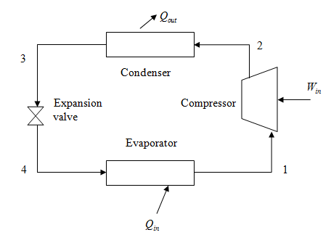

Figure 2

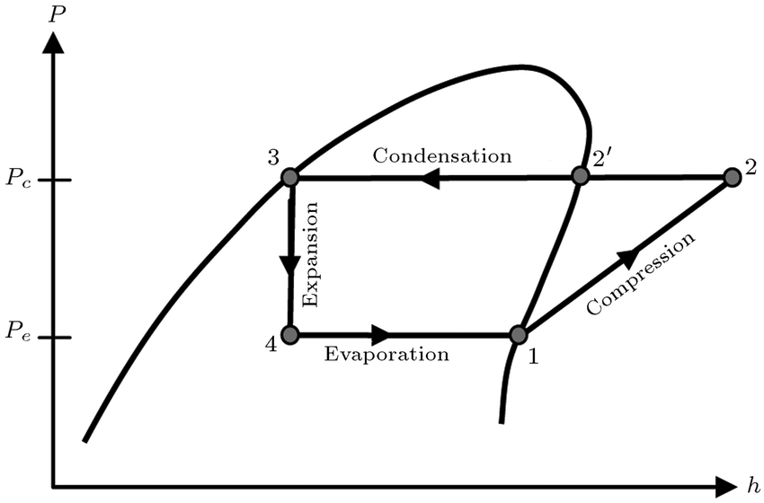

Figure 3

DUAL EVAPORATOR SYSTEM

Eventhough working of Refrigeration cum Air conditioner is based on VCRS there is a slight modification in our system. Instead of a single evaporator we are using two evaporators to perform two actions such as refrigeration and air conditioning.. Thissystem consists of a single compressor, single condenser, arefrigerating evaporator (evaporator 1), an air-conditioningevaporator (evaporator 2), and individual expansion valve.

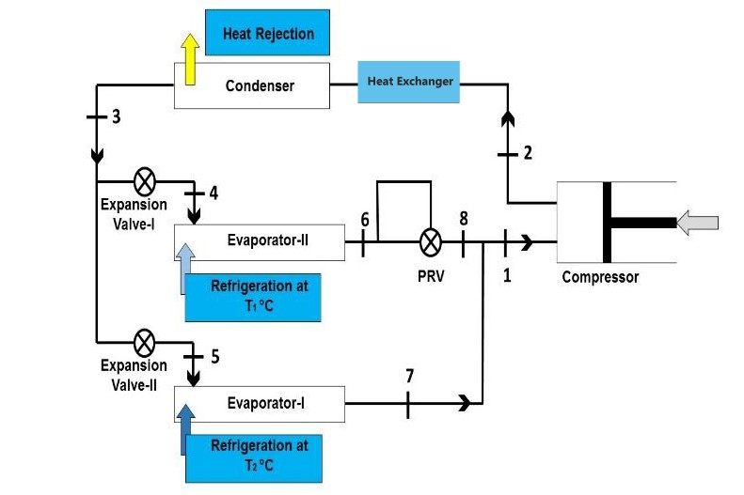

Figure 4

6. DESIGN

Refrigerator cum air conditioner system which has two parts the upper part is for air conditioner and the lower part is for refrigerator. This system consists of a single compressor, single condenser, a refrigerating evaporator (evaporator 1), an air-conditioning evaporator (evaporator 2), and individual expansion valve.

 The fan and blower is used in an air conditioner for pumping and circulating the air through the entire duct system and the conditioned space. It is usually located at the inlet of the air conditioner. A fan essentially consists of a rotating wheel, which is surrounded by a stationary member known as housing. There are many types of refrigerants available for getting cooling effect. We are using a tetra fluoro-ethane (R 134a) as a refrigerant to get cooling effect because it does not contain chlorine and its ozone depleting potential is zero. This system can be move from one place to another place by providing the wheel. In past, to operate such a unit two different refrigeration cycles were used which increases cost and also require more space and power but in this case by using a multi evaporator refrigeration system we can operate the total unit in minimum cost, space and power.

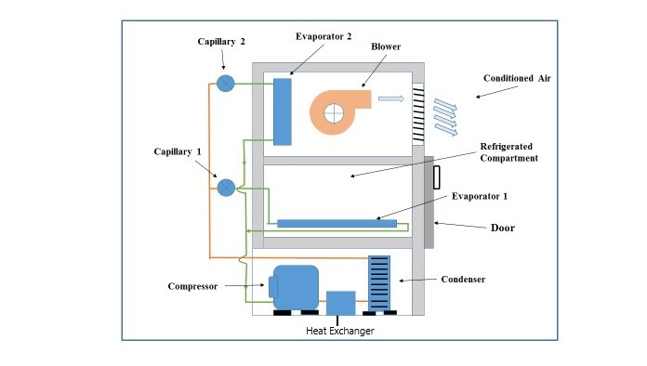

Figure 5

7. WORKING



Figure 6

The arrangement consists of two evaporators, evaporator I and evaporator II operating at different temperatures with single compressor. This system also uses individual expansion valves EV-1 and EV-2 and pressure regulating valve.

In the first stage of the refrigeration cycle, refrigerant enters a compressor as a low-pressure vapor. The compressor compresses the refrigerant to a high-pressure vapor, causing it to become superheated. Once the refrigerant is compressed and heated, it leaves the compressor and enters the next stage of the cycle. After leaving the compressor, the hot vapor refrigerant enters the next stage of the cycle, condensation. During the condensation stage, the refrigerant enters a condenser and flows through a series of S-shaped tubes. As the hot vapor flows through the condenser, cool air is blown across the tubes by a fan. Because the air being blown across the tubes is cooler than the refrigerant, heat transfers from the tubing to the cooler air. This heat transfer causes the hot vapor refrigerant to reach its saturated temperature, which then changes its state to a high-pressure liquid. Once the refrigerant is in a high-pressure liquid state, it is ready to leave the condenser and move on to the metering and expansion stage of the cycle. The third stage of how compression refrigeration systems work consists of the high-pressure liquid refrigerant entering a metering device or expansion valve. The metering device works to maintain high-pressure on the inlet side, while also expanding the liquid refrigerant and lowering the pressure on the outlet side. During the process of expansion, the temperature of the liquid refrigerant is also reduced. In a cool, low-pressure liquid state, the refrigerant is now ready to enter the evaporation stage, which is where the heat is finally removed from the space being conditioned. The pressure of refrigerant coming out of the high temperature evaporator i.e. evaporator II at high pressure is regulated by a pressure-regulating valve (PRV) at point 8. Now the refrigerant leaving the PRV at pint 8 are mixed with the refrigerant leaving the Evaporator I at point 7, at the pressure of Evaporator I, which is the suction, pressure of the compressor. This system offers the advantage of higher refrigeration effect at the high temperature evaporator.

The COP of the above system is given by:

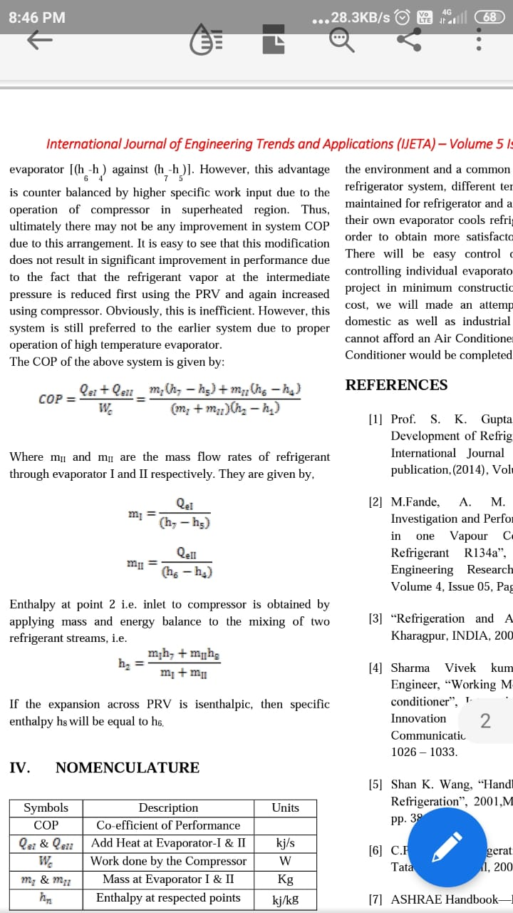

Equation 1

Where mI and mII are the mass flow rates of refrigerant through evaporator I and II respectively. They are given by,



Equation 2

Enthalpy at point 2 i.e. inlet to compressor is obtained by applying mass and energy balance to the mixing of two refrigerant streams, i.e.



Equation 3

If the expansion across PRV is isenthalpic, then specific enthalpy h8 will be equal to h6.

8.COMPONENTS

1. Compressor

There are two outcomes from compressor one is for suction and other is for discharge. The compressor sucks the vapor refrigerant from evaporator and discharge to condenser. The compressor is simple V type reciprocating, single stage, single acting and hermetic sealed type compressor.

**Function**: Compresses and circulates refrigerant throughout the cooling system and increase the temperature and pressure at condense level.

2. Condenser

The condenser tubes are made from copper and having 8 mm diameter. The condenser cooling is natural convection air cooled condenser. The condenser contains the plate type fins which increase the area for heat transfer. These fins are normally made from aluminum because of lower weight. These tubes are bended by means of the spring bender. The main function of the condenser is to condense the refrigerant.

**Function**: In this process the refrigerant converted into liquid form from vapor form.

1. Expansion Valve

In this process due to reduce in pressure the half portion of the liquid is converted into vapor form. The expansion devices used in model is simple capillary tube. This device reduces the high pressure liquid refrigerant to low pressure liquid refrigerant. The expansion devices separate the high pressure and lower pressure side.

1. Evaporator

In this process due to reduce in pressure the half portion of the liquid is converted into vapor form. The expansion devices used in model is simple capillary tube. This device reduces the high pressure liquid refrigerant to low pressure liquid refrigerant. The expansion devices separate the high pressure and lower pressure side.

The liquid refrigerant from the expansion valve enter into the evaporator and in this evaporator the liquid is converted into vapor.

5 .Base structure of Refrigerator cabin

The four angles are joined by arc welding and on which the wooden sheet is fastened by bolts. The base structure of model was made from the M.S. steel and wooden sheet. This base structure is providing the support to all part of model.

6. Refrigerator Cabin

The cabin for refrigeration system is made from PVC smart wood. This cabin separated inside in two parts one is refrigerator and second is air conditioner. This cabin is coated by thermocol sheet inside.

7. Refrigerant

The refrigerant is a heat carrying medium which absorb heat from low temperature side and release it at high temperature side. The refrigerant use in this system is R-134a (Tetrafluoroethane). It has boiling temperature -26.15 C. It is not soluble in oil. The refrigerant used in system is primary organic refrigerant.

Properties: Ozone Friendly, Easily Available, Safe refrigerant.

8. AIR HANDLING UNIT

1. Blower/Fan

The blower is used to suck the cooled air from the refrigerant unit and produce the effect of air conditioner. The fan use for the circulation of air and increase cooling effect.

1. Filters:

Air filtration is necessary as the air may comprise of dust particles.

1. Dehumidifier:

A perforated membrane is used to reduce relative humidity.

9.Voltage Controller

This voltage controller is used for the controlling speed for blower.

10.Pressure Gauge

The outlet pressure is a discharge pressure of compressor and for it discharge pressure gauge is used. The inlet pressure is a suction pressure of the compressor so pressure gauge used for it suction pressure gauge. The pressure gauge is used for measuring the pressure at inlet and outlet of compressor.

11.Heat Exchanger

A copper tube is used to extract the unused heat which is released from the condenser.

9. MATERIAL SELECTION

**1.Compressor details**

* Power: 1 HP
* Type: Reciprocating Compressor
* Cooling Method: Air cooled

**2.Condenser Type**:

* Air Cooled – Forced Convection Type

**3.Evaporator Type**:

* Plate Surface Evaporator – Freezing Type
* Material: Copper

**4.Heat Exchanger**:

* Copper Tubes with plate

**5.Refrigerant**:

* R134a (Tetra Fluro-Ethane)

**6.Refrigerator Cabin**

* The cabin for refrigeration system is made from PVC smart wooden structure.

10. RESULT& DISCUSSION

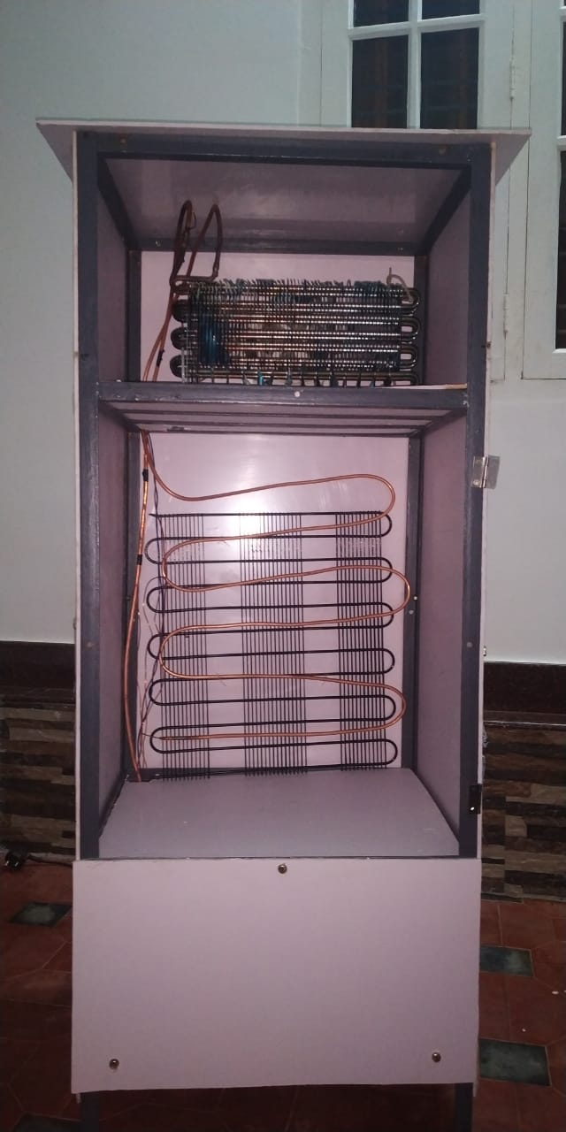

Figure 7

* A working model of Refrigerator cum Air conditioner.

The product we had developed can be used as a refrigerator and air conditioner. This will help us tackling the problem of lacking power resources as this Refrigerator cum Air conditioner make a personal cooling system.

* Recovering unused heat from condenser

Using heat exchangers we had extracted the unused heat that is rejected from the condenser. Actually heat rejected from the condenser further heats the room. So by means of heat exchanger we are not only using the unused heat but also improves the efficiency of our air conditioner.

* Heating of water using waste heat rejected by condenser.

The unused heat recovered is used to heat the water in a small container with a capacity of 5L.

* Capable of performing Refrigeration, Air Conditioning and Water Heating.

Refrigeration cum Air conditioner is a personalised cooling system which will run at low cost that can be used for 3 different purposes such as refrigeration, air conditioner and water heater

* Less energy consumption as compared to individual units.
* An optimized unit affordable by a common man.

Even though air conditioners are available and established over a century, it is still not affordable by a common man. By introducing refrigeration cum air conditioner to the market it will be an optimised unit affordable by a common man. Instead of buying 3 products one single product could perform 3 operations.

11. FUTURE SCOPE

Refrigeration cum Air conditioner could be used in various applications such as

* **Households**

In households during summer season, the necessity of air conditioner and refrigerator is not doubtful at all. So our experiment will be beneficiary for many households in many ways. The heated water is also useful in many household activities.

* **Hospital**

In hospitals some medicines have to be kept below room temperature so the need refrigerator is compulsory. At the same time air conditioning is also important inorder to keep the staffs and patients comfortable. By using our product we could achieve both. And also the heated water inside our refrigerator can used in hospitals for sterilisation or other uses.

* **Food storage trucks**

Some food products have to be preserved under room temperature while transporting them. By using our refrigeration cum air conditioner we could refrigerate the storage truck and condition the air inside the driving cabin at the same time using a single unit.

12. CONCLUSION

This paper study about the attempt to make a working model of Portable Refrigerator cum Air conditioner system to reduce power consumption, space and cost such that to make the environment and a common man comfortable. In Ac cum refrigerator system, different temperatures are required to be maintained for refrigerator and air conditioning. In such cases, their own evaporator cools refrigerator and air conditioner in order to obtain more satisfactory control of the condition. There will be easy control of fluctuations in loads by controlling individual evaporator. To fulfilled the aim of the project in minimum construction, maintenance and running cost, we will made an attempt which is quite useful for domestic as well as industrial purpose so that those who cannot afford an Air Conditioner can have the comfort of Air Conditioner would be completed.

By recovering the unused heat from condenser we could maximize the energy utilization and minimize the heat rejection. Thus this product will have higher efficiency compared to any other devices

REFERENCES

[1] Prof. S. K. Gupta, “Feasibility Study and Development of Refrigerator cum Air Conditioner”, International Journal of scientific and research publication,(2014), Volume4, Issue12.

[2] M.Fande, A. M. Andhare, “Experimental Investigation and Performance Evaluation of a Threein one Vapour Compression System using Refrigerant R134a”, International Journal of Engineering Research & Technology, (2015),Volume 4, Issue 05, Pages 1109-1112.

[3] “Refrigeration and Air Conditioning”, EE IIT,Kharagpur, INDIA, 2008.

[4] Sharma Vivek kumar, Kiritbhai, Mechanical Engineer, “Working Model of Refrigerator cum Airconditioner”, International Journal on Recent and Innovation Trends in Computing andCommunication, (2017), Volume 5, Issue 6, Pages1026 – 1033.

[5] Shan K. Wang, “Handbook of Air Conditioning and Refrigeration”, 2001,McGraw-Hill, Second Edition,pp. 38-60.

[6] C.P.Arora, “Refrigeration and Air Conditioning”,

Tata-McGraw-Hill, 2003.

[7] ASHRAE Handbook—Refrigeration

[8] Jin-Long Lin, T.-J. Yeh, “Identification and control of multi-evaporator Air-conditioning systems”, International Journal of Refrigeration 30 (2007),ELSEVIER, 1374e1385.