CHAPTER 1
INTRODUCTION
Arecanut is an erect, unbranched palm reaching heights of 12-30 m, depending upon the environmental conditions. Researchers all around the world work on developing climbing machines, most of these climbing machines are capable of climbing regular structures like poles, walls etc. But a very few are capable of climbing trees, main reason being irregular surface and variation of diameter. It also requires greater agility to be used as a product. Also the bark of some trees may not be strong enough to bear the weight of the climbing device, hence conventional climbing machine cannot be used for tree climbing applications . Many trees like coconut tree, arecanut tree, and palm trees are so tall that climbing them becomes risky. Hence harvesting fruits and nuts and maintaining them becomes difficult. So development of a unique tree climbing mechanism is necessary which may be used for maintaining and harvesting applications.
In recent years, labour scarcity has emerged as one of the foremost challenges in farming. One crop that has been most affected by this is the arecanut. Arecanut trees attain a height of about 12-30 m. It is mandatory to climb the trees a minimum of five times a year for a successful harvest - twice for the preventive spray against fungal disease, and thrice to harvest the arecanut.Only skilled labourers can carry out these farming operations. They have to climb the trees using muscle power. As this involves real hard, physical exertion, younger generations of labourers are losing interest, with potentially harsh implications for arecanut cultivation. The spraying is done in monsoon, while harvest time is typically in summer. The scope of this project is limited to climb arecanut trees having circumference between 30 and 50 cm. Therefore, maintaining sufficient friction force capable of handling the self-weight, maintaining the stability of the structure while in motion, reducing the total weight, and achieving the precise gripping are the important parameters that have to be considered. The machine should be capable of adjusting to the varying cross-section of the tree during upward and downward movements. The machine should grab the tree firmly to maintain its positions during the operation. The retractive force of the spring should be good enough for the climbing up of the tree . In this project, considering all the above parameters, a safe, reliable and efficient climbing machine is designed and fabricated.

1.1 OBJECTIVES
In an attempt to assist the climbers, an arecanut tree climbing device has been designed to meets the following goals.
- It will be controlled from the ground.
- Both men and women will be able to operate the device.
- The arecanut tree climber will be able to harvest faster than present methods.
Mechanisation of conventional methods used in harvesting the crops is very much essential to assist the farmer. The aim is to build a prototype that can successfully climb an arecanut tree of variable diameters and height.

CHAPTER 2
LITERATURE REVIEW

An areca nut tree climber was constructed by J.Sharana Basavaraja1 in 2015to climb the areca tree by applying force on both the pedal alternatively. The product has two units left and right, each unit consist of a T-gripper assembly which locks the areca tree, a box -beamassembly which acts as a supporting member of the areca tree climber product, pedal assemblycreates the up and down operation of the climbing unit. Initially the climbing unit is fitted at the base of the tree. When the force is applied on the pedal of right climber unit it creates the grip through the steel wire rope that is connected from T-gripper to the pedal, thus creating the grip to lock the arecatree, The left climber unit is now pulled up by using the handle that is attached to the T-gripper assembly. The areca tree is climbed to the maximum height by repeating the operation; the reverse operation is followed to descend the areca tree . The device according to the invention will be able to do the work faster, cheaper and much more safely for a much lower price[1]. Another design of the device by Gokulraju R has to be simple enough for villagers to operate and also it is safer as compared to other tree climbing machines. This is the most suitable machine for harvesting areca nuts without man climbing on the tree and also we can reduce the time for harvest the nuts from tree. There we use a rope and pulley mechanism to operate this machine. There we use a special type of knife to cut the areca nut and by using the rope we can bring the machine down . The analysis done using ANSYS proved the design to be safe and the fabrication was completed successfully[2].
And also design and fabrication of arecanut tree climbing and spraying machine is presented by M. Tony and C. Johny. The device consists of a triangular base frame which supports all the components to be built upon. It is fitted with three DC motors - nylon tyres with rubber grippers at 120 degrees each other for ease of the operations. A specially designed remote controlled spraying unit is mounted on the frame. Power from the battery is supplied to the motors using flexible wires and DPDT (Double Pole Double Throw) switch is used to control the movement of climbing machine as well as spraying unit. DC geared motors having reduction gears which ensures self-locking of the tyres and thus maintains the height. To accommodate for change in the diameter of arecanut tree as the device moves up and down, a spring loaded mechanism is used for exerting sufficient tension required for gripping the tree. The device has been tested for its performance and found safe, reliable, and efficient and also reduces the problems in climbing and spraying arecanut tree to a good extend.After testing the machine it has been found that the design is efficient in climbing the tree very smoothly without damaging the tree[3].

CHAPTER 3
PROBLEM IDENTIFICATION
- There is low availability of workers available for climbing the arecanut tree.
- During rainy season it is risky to climb the trees
- It is very difficult to climb long trees
- Some trees are decayed due to fungal attacks
- Women cannot able to climb the arecanut trees

3.1 SCOPE

- To reduce the climbing time and the power source requirement is one of the aims of the project.
- To design an Eco friendly product
- To overcome the wear and tear of the product it is desired to design a product with less repairand maintenance problems.
- There is a need to develop the product that can be operated by both men and women.

CHAPTER 4
DESIGN
4.1 DESIGN OF SPRING
Outer diameter, D_{O}=34mm
Wire diameter, d=2mm
Number of coils, N=50
Length, L=100mm
Material for the spring is stainless steel
From data book :
Young's modulus, E=210 GPa
Poisson's ratio, ʋ=0.3
Mean diameter, D= D_{O}-d =32mm
Spring index, C=D/d = 32/2 =16
Shear modulus, G =$\frac{E}{2(1+ʋ)}$
= $\frac{210×{10}^{9}}{2×(1+0.3)}$
= 8.0769$×{10}^{10} Pa$
$$G =8.0769×{10}^{4 }MPa$$
Stiffness, k =$\frac{Gd^{4}}{8{ND}^{3}}$
$=\frac{8.0769×{10}^{4}×2^{4}}{8×50×{32}^{3}}$
$k =$0.1 N/mm

Spring Force, F_{S} = k δ
$=0.1×1000=100N$
Output Force, F_{o} = Spring Force, F_{S} = 100N

Two pulleys will reduce the input force ,the operator need not apply Fup but less than it .Here we use two pulleys and the mechanical advantage is two.
Input Force = F_{i} = $\frac{1}{2}$ F_{s} =50N
Total Upward Force = Spring force - Weight of the machine - Friction(neglected)
F_{s} - 8$×9.81$
F_{up} = 21.52N

4.2 2D DESIGN
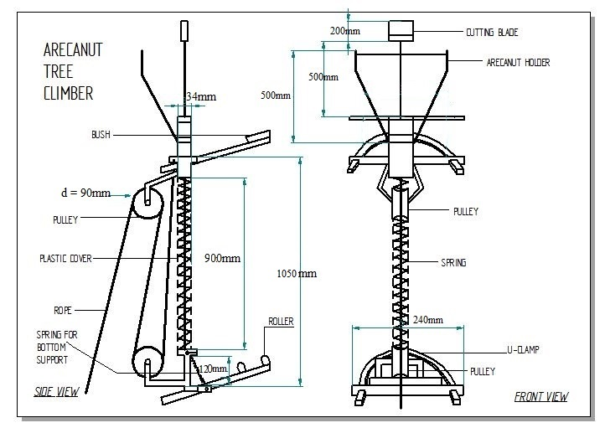
Figure 4.2.1 : 2D Design

4.3 - 3D DESIGN

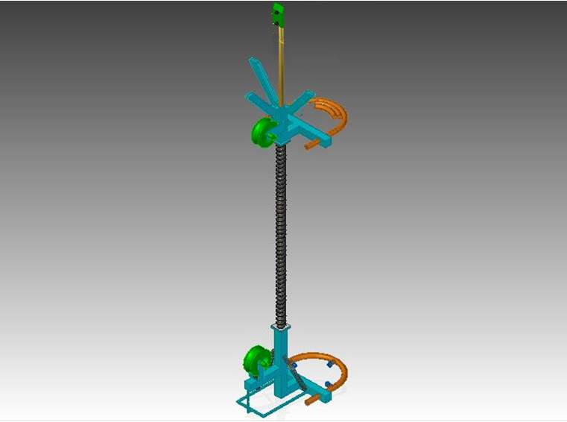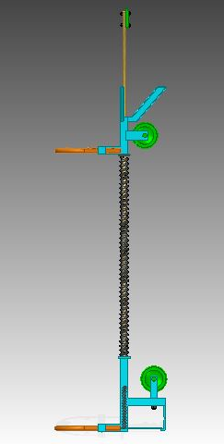
Figure 4.3.1 : 3D Design

CHAPTER 5
PARTS
5.1 OPEN COILED SPRING
It is also known as compression spring. Since the open-coiled helical springs are not wound very tightly, the pitch of the spring is much greater. Due to the space between the coils, one round of the spring does not lie in the same plane as the axis of the helix. Hence, no two turns of a spring will lie in the same plane. As compared to closed coiled helical springs, where the angle formed between the turn and the helical axis is 90˚, the turns of the open coiled helical springs form an inclined angle with the helical axis. The pitch and the distance between the coils is the major point of distinction between the two types of helical springs.
Here the spring material is stainless steel
Outer diameter, D_{O} = 34 mm
Wire diameter, d = 2 mm
Number of coils, N = 50
Length, L = 100mm
Stiffness, k = 0.1 N/mm
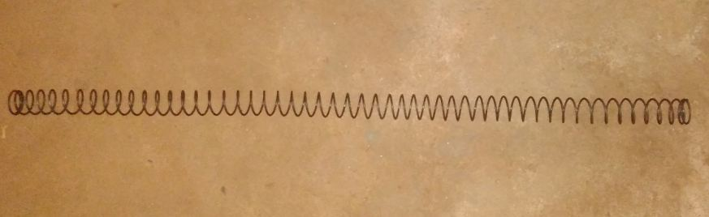
Figure 5.1.1 : Spring

5.2 U-CLAMPS
A U-Clamp is a clamp in the shape of letter U with threads or having holes to provide the hooks on the both ends. U-clamps are primarily used to support pipe works, pipes through which fluids and gases are passed. Here we are using the u clamps to attach the areca nut tree climber to the areca nut tree .The material of the u clamp used here is stainless steel and having a diameter of 20cm.it is having a length of 20cm .
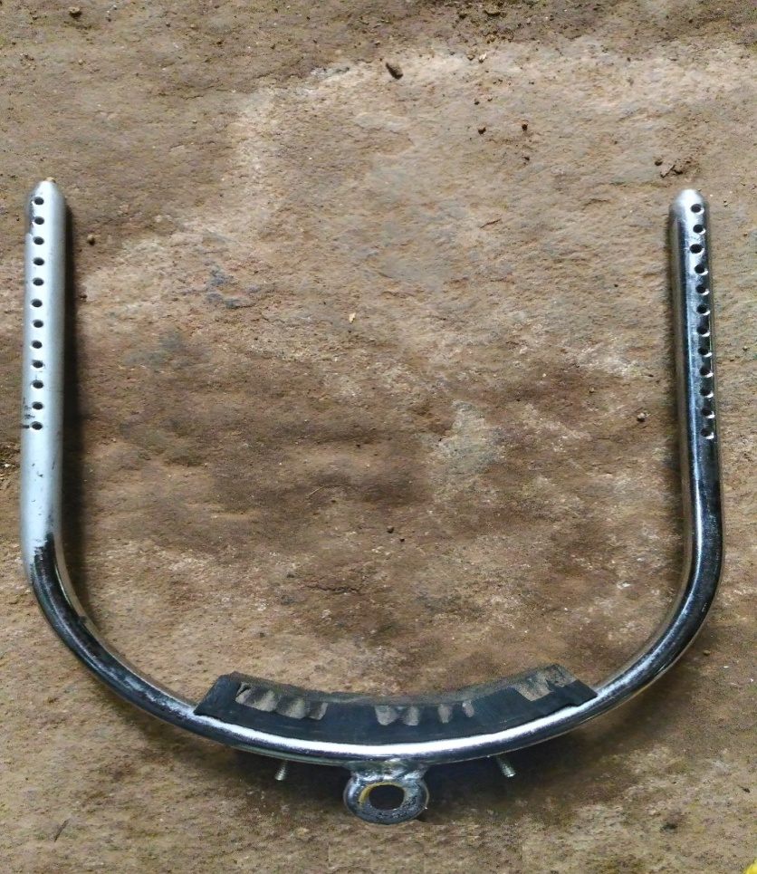
Figure 5.2.1 : U Clamp
5.3 PULLEY
A pulley, also called a sheave or a drum, is a mechanism composed of a wheel on an axle or shaft that may have a groove between two flanges around its circumference. A rope, cable, belt, or chain usually runs over the wheel and inside the groove, if present. Pulleys are used to change the direction of an applied force, transmit rotational motion, or realize a mechanical advantage in either a linear or rotational system of motion. A belt and pulley system is characterized by two or more pulleys in common to a belt. This allows for mechanical power, torque, and speed to be transmitted across axes and, if the pulleys are of differing diameters, a mechanical advantage to be realized.
Here two pulleys of diameter 10cm are used and are made of plastic.

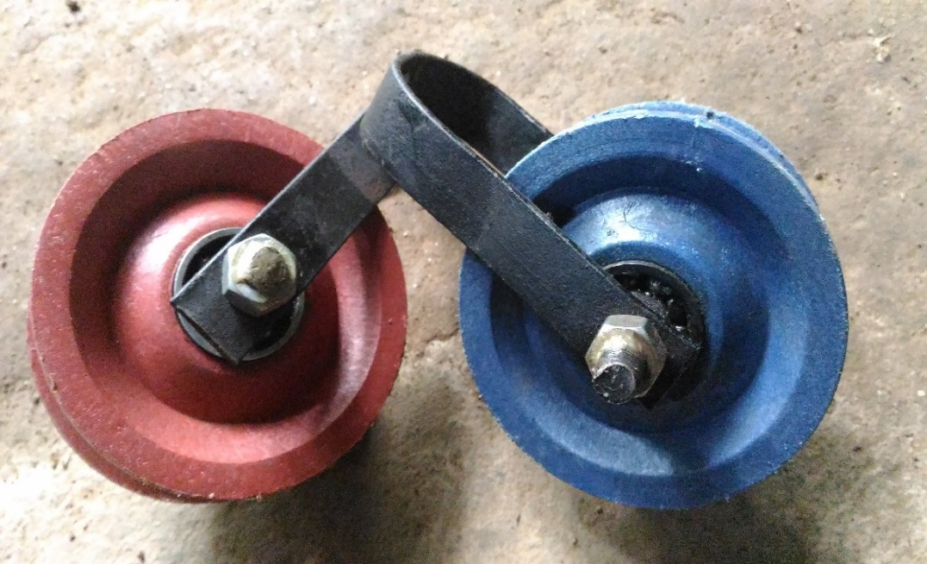
Figure 5.3.1 : Pulleys

5.4 SQUARE ROD
The square rods are used to fabricate the main frame and tool holder of the arecanut tree climber .Here we are using 25$×$25 , 20$×$20 , 16$×$16 mm square rod that is made up of mild steel.

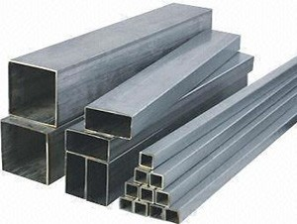
Figure 5.4.1 : Square Rods
5.5 HOOKS
A hook is a tool consisting of a length of material, typically metal, that contains a portion that is curved or indented, such that it can be used to grab onto, connect, or otherwise attach itself onto another object. In a number of uses, one end of the hook is pointed, so that this end can pierce another material, which is then held by the curved or indented portion.
Here we are using old umbrella ribs for making the hooks. They are made of stainless steel. These are inserted into the holes of the u clamp to fix the main frame onto the arecanut.
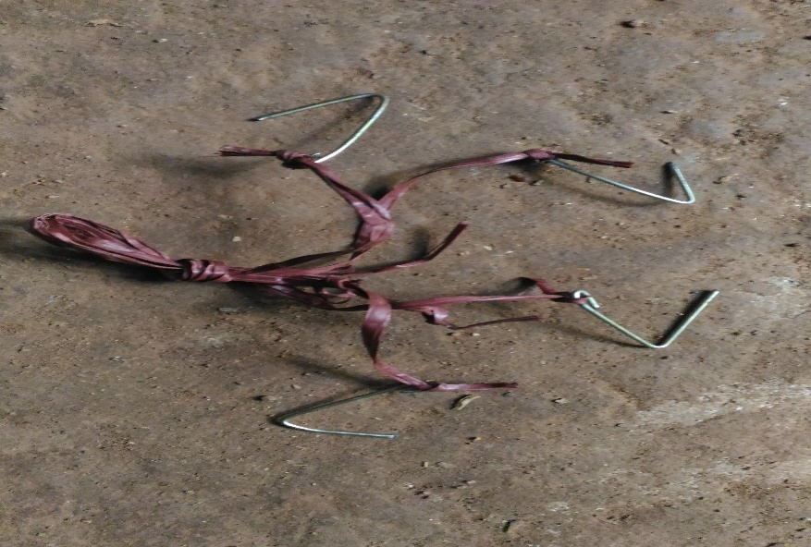
Figure 5.5.1 : Hooks
5.6 ROPES
A rope is a group of yarns, plies, fibers or strands that are twisted or braided together into a larger and stronger form. Ropes have tensile strength and so can be used for dragging and lifting, but are too flexible to provide compressive strength. As a result, they cannot be used for pushing or similar compressive applications.
We are using two types of ropes (plastic) having diameters of 10mm and 6mm respectively. The two ropes are about 15-20m long .Here the ropes are used to compress the spring for the upward movement and for the downward movement of the equipment.
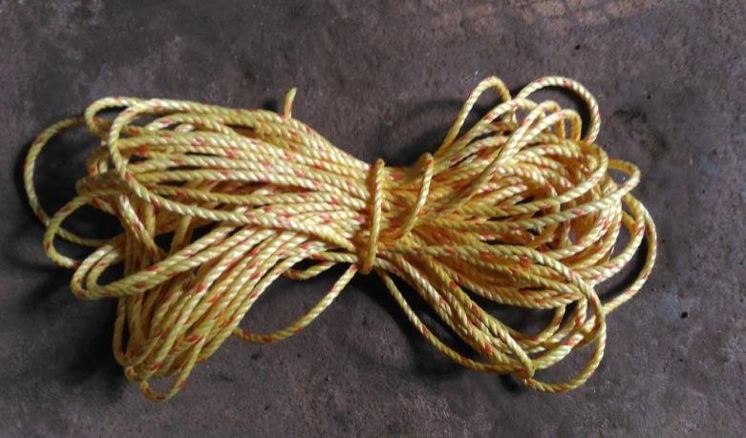
Figure 5.6.1 : 6mm Rope
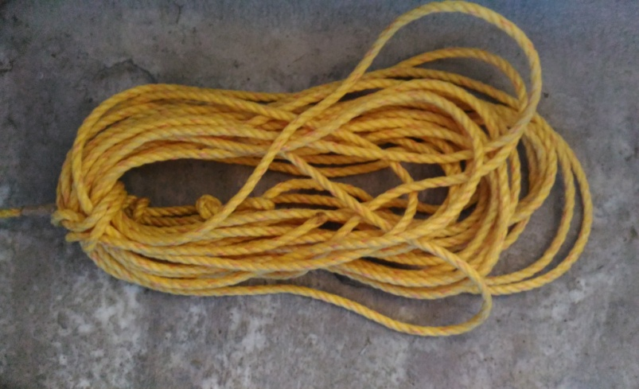
Figure 5.6.2 : 10mm Rope

5.7 CUTTING BLADE
Cutting blade is used for cutting the arecanut bunch from the arecanut tree .It is made up of stainless steel and is attached to the main frame by a square metal rod of 16$×$16 mm
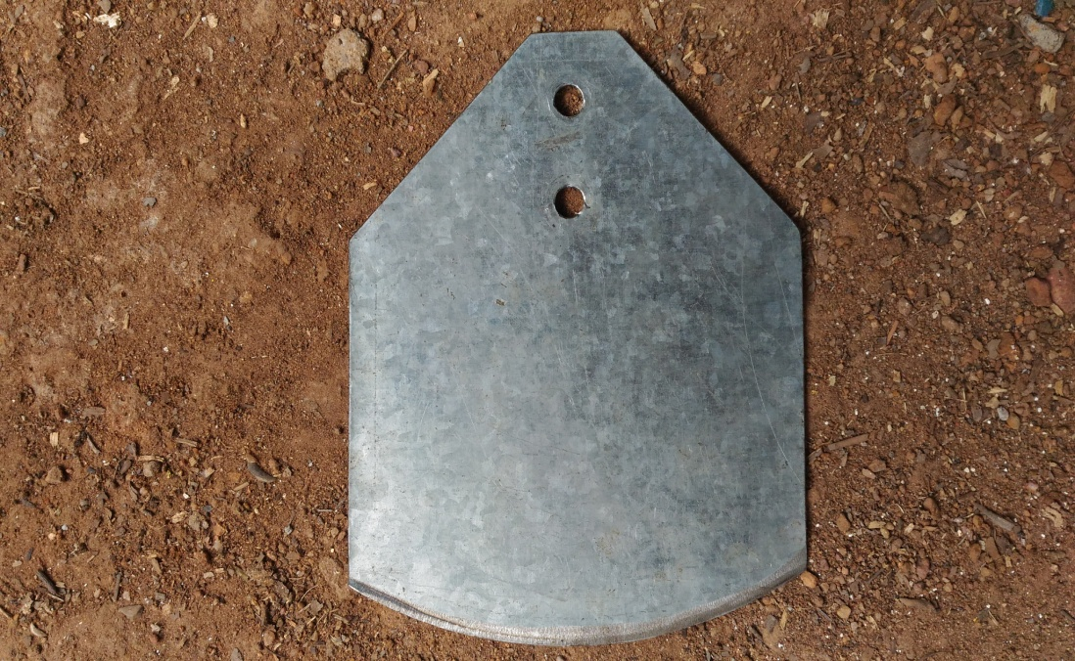
Figure 5.7.1 : Cutter Blade
5.8 BUNCH HOLDER
Bunch holder is a part of arecanut tree climber which is used to hold the arecanut buch after cutting it. It is made up of mild steel rod of diameter 10mm and it is attached to the main frame
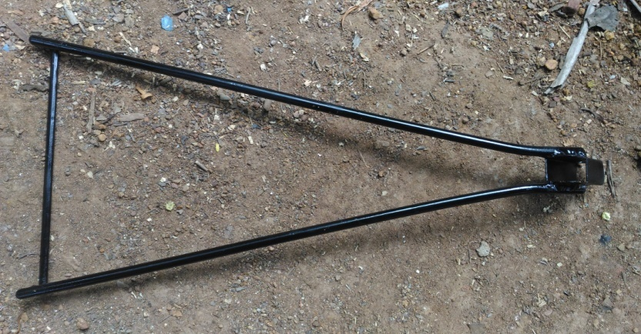
Figure 5.8.1 : Bunch Holder
5.9 CLOSED COIL SPRING
It is also known as tension or extension spring .Here the helical springs are wound tightly ,pitch of the spring is very small. This spring is used in the lower portion of the main frame to restrict the downward motion of the equipment .

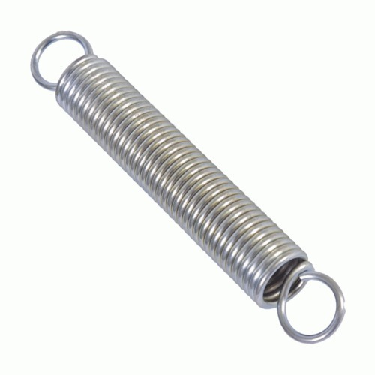
Figure 5.9.1 : Spring
5.10 NUTS AND BOLTS
A nut is a type of fastener with a threaded hole. Nuts are almost always used in conjunction with a mating bolt to fasten multiple parts together. The two partners are kept together by a combination of their threads' friction (with slight elastic deformation), a slight stretching of the bolt, and compression of the parts to be held together.
bolts.A bolt is a form of threaded fastener with an external male thread. Bolts are closely related to, and often confused with, screws. Here we are M 10 nut and bolt.

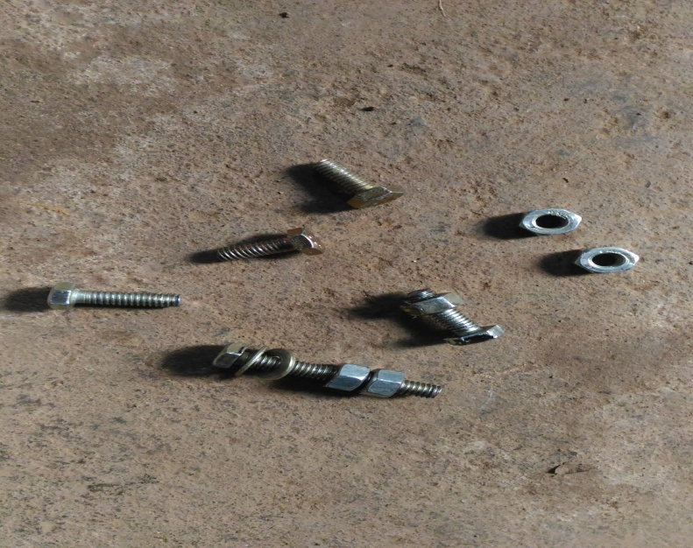
Figure 5.10.1 : Nuts and Bolts
5.11 FULL ASSEMBLY

CHAPTER 6
WORKING
The arecanut tree climbing works on the basic principle of friction that is the relative lateral motion of two solid surfaces in contact. The machine developed consists of a central open coiled spring which is the main part of the equipment. The figure shows the rough sketch of the arecanut tree climber .The equipment is mainly divided into two parts, upper and lower .One pulley is attached to the upper part and one is attached to the lower part.A single rope is attached to the upper part and taken through the two pulleys as shown in the figure.
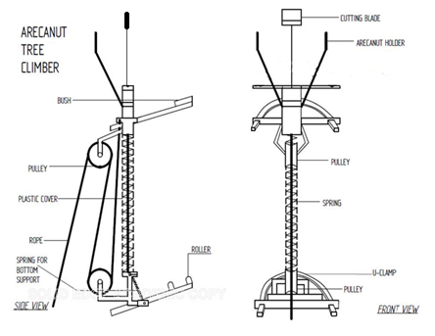
Figure 6.1 : 2D view
Two pulleys and a rope is used to control the compression and expansion of the spring .When a force is applied on an open coiled spring it get compressed and when the applied force is released it will return to its original position due to the retractive force of the spring .This principle is used for climbing the equipment on the tree . A U-clamp is used to fix the equipment on the arecanut tree .A auxiliary spring is attached to the u clamb for the proper gripping of the equipment to the arecanut tree . A central metal rod along with the cutter blade at one end is placed through the centre of the open coiled spring . An arecanut holder is attached to the upper part of the equipment to collect the bunch of arecanut that is cut by the cutter blade.
The working is in such a way that firstly the equipment is attached to the arecanut tree by using the u clamp according to the size of the arecanut tree .then the roller belt is placed and necessary parts are tightened .When the rope is pulled downwards the upper part of the equipment is made fixed by the rubber grips provided on the u clamps .so sufficient frictional resistance is obtained . At the same time the lower pulley moves upward by moving the lower part .The auxiliary spring will helps to loose the lower u clamp and allows the upward motion of the lower part .Due to the pull on the rope the central spring will get compressed along with the upward motion of the blade . And when the rope is released due to the retractive force of spring , the upper of the equipment moves upward . This process is continued till the equipment reaches the top of the arecanut tree . then the bunch of arecanut is cut using the cutter blade provided. The bunch of arecanut that is cut is collected in the collector .Another rope is provided on the lower clamp inorder to reduce the friction between the bush and tree for lowering the equipment with the arecanut.

6.1 CHALLENGES
The current invention comes with many challenges. The device must attach to the base of the tree and be easily removable, the wheels must maintain adequate contact with the tree as the tree diameter decreases during ascension, and a single user must control it to a height of approximately 30m. However, the ultimate goal is to actually harvest arecanuts. Once the basic tree climber is completed and it can ascend and descend a tree successfully, we will face more major challenges: the lack of vision as the device climbs upwards and finding an actual bunch of arecanut. Finally, testing the prototype on actual arecanut trees will be difficult.
Another challenge faced here is the difficulty in climbing trees where other trees branches acts as a barrier.This wont allow the climbing of the machine.Also we cannot use this machine where there are climbers like pepper.Another challenge is climbing a little bit sloped trees.
CHAPTER 7
ADVANTAGES & DISADVANTAGES
7.1 ADVANTAGES
- Lower maintenance costs.
- It reduces time and dependence on labour.
- This is the most suitable machine without man climbing on the tree.
- It can be controlled from the ground.
- Both men and women will be able to operate the device.
- The arecanut climber will be able to harvest as fast or faster than present methods.
- It eliminates the risk involved in manual climbing of the areca tree.

7.2 DISADVANTAGES
- The lack of vision as the device climbs upwards.
- Difficult to climb when there are obstructions like other trees branches.
- Difficult to control the machine while climbing sloped trees.

CHAPTER 8
CONCLUSION

The product arecanut tree climber replace the common technology used today especially for arecanut trees . The Product can reach to any desired height without risk to a person or damage to the surface of the tree and harvest at different angles without any risk. The price of the proposed device can be low enough for the climbers to afford. The device according to the present invention will be able to do the work faster, cheaper and much more safely for a much lower price.
The design is efficient in climbing the tree very smoothly without damaging the tree.The tree climber doesn’t require a human to physically climb the tree, hence reducing the danger to the climber. The design is simple and appealing to the majority. An unskilled labour can operate the machine safely and efficiently. By installing properly designed sprayers or cutting device many number of trees can be harvested in a single climb thus increasing the efficiency.

REFERENCE

[1] J.Sharana Basavaraja, Nagaraja ,Somashekar H Hegde, 2015 , Design and
Development of Areca Tree Climber ,B M S College of Engineering.
[2] Gokulraju R, Vigneshwar K, Aravind Balakrishnan, Bibin Narayanan, 2017, Arecanut Tree Climber ,Akshaya College of Engineering & Technology India
[3] M. Tony, C. Johny, S. Sayooj, K. Yathish, J. P. Vas,2016, Design and Fabrication of Arecanut Tree Climbing and Spraying Machine, St Joseph Engineering College, Mangalore, India.
[4] Ahmed Salih Mahdi. Al-Zuhairi – Semi automatic tree climber - in International Journal of Agriculture & Research (IJAR) – Volume 4 Issue 7–July 2013.
[5] N S Kannur - Design And Fabrication Of Coconut Tree Climbing Equipment - International journal of innovative research in science ,engineering and technology

