**1. INTRODUCTION**

Clean emission profile, non toxic, ease of use and huge dependence on foreign petroleum products made biodiesel become one of the fastest growing alternative fuels in the world. Physico-chemical properties of vegetable oils like high density and viscosity, low volatility and formation of carbon deposits tend to limit their use as fuel in diesel engines. It was experimentally proven and worldwide accepted that the transesterification process is an effective method for biodiesel production and to reduce viscosity and density of vegetable oils. The transesterification process is a reversible reaction between the triglycerides of the vegetable oil and alcohol in the presence of an acid or base as catalyst. As a result of transesterification the monoalkyl esters of the vegetable oil are formed and glycerol is produced as a byproduct in the process.

The Government of India envisaged setting up of the National Biofuel Board to develop a road map for the use of biofuels, besides taking appropriate policy measures. In order to promote biodiesel and its production, the Ministry of Petroleum and Natural Gas announced the biodiesel Purchase Policy in October 2005. The policy provided for the purchase of biodiesel at 20 specified purchase centers in 12 states at Rs. 25/litre (inclusive of taxes and duties) from January 2006, moreover, the Government of India fully exempted biodiesel from excise duties in the Union Budget of February 2007. The Indian government also announced, on 23rd December, 2009, attractive incentives to encourage biofuels plantation in wastelands and to utilize indigenous biomass feed stocks for the production of biofuels. It addresses the issues across the entire value chain from plantations and processing to marketing of biofuels. India’s new policy on biofuels targets blending at least 20% biofuels in diesel and petrol by 2017. This implies that 13.38 million tons of biodiesel will be required.

1.1 RICE BRAN OIL

Rice bran is a by-product, obtained from the outer layers of the brown (husked) rice kernel during milling to produce polished rice.

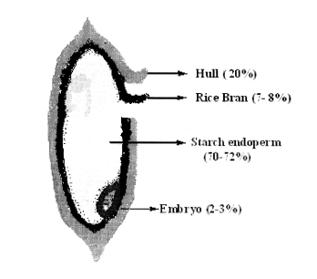

Fig 1.01 structure of rice kernel

Preparation of rice bran involves reduction of moisture content from 12% to 6% in an expeller by steam jacketing. The treatment besides reducing the moisture content of bran, increases particle size and imparts a hardening effect to bran particles for better extractability, better filtration time and reduction of fines problem. The pre-treated bran after being turned to flakes is fed to extraction column. The extraction can be either batch or continuous. The bran flakes is seated on the false bottom provided in the extractor with coir mat as filter element. After maintaining a vacuum of 25" Hg in the extractor, solvent normally hexane is drawn into the extractor which is a counter current multistage type and the extraction is carried out in hot condition, since it helps in quick and efficient extraction, the oil which gets dissolved in the solvent is withdrawn from the bottom as concentrated miscella. The solvent retained with the bran is recovered finally and reused. The distillation of concentrated miscella is carried out at a temperature of about 75- 80° C, when more volatile component, hexane vaporize leaving behind the oil. The vapors of the solvent are condensed and reused. The oil with 4% solvent is taken from the bottom to a stripping column. The crude oil with about 4% solvent is fed to the stripping column, which has block of gravels placed on a perforated plate as a packed column. The oil is stripped off the solvent by open steam injecting and the solvent vapors recovered are reused after condensation. The oil along with the condensed steam is taken by gravity into a tank called post-dissolventiser. In the post-dissolventiser, the oil along with condensed steam from stripping column is kept for 2 to 3 hours, when water gets separated and the oil is taken to the oil tank where the oil is given salt wash to separate the sludge, gums etc. in the oil. This is the crude rice bran oil, which can be used for manufacture of soap, biodiesel, emulsifiers, fatty acid, plasticisers, cosmetics and tocopherol (vitamin E) etc.

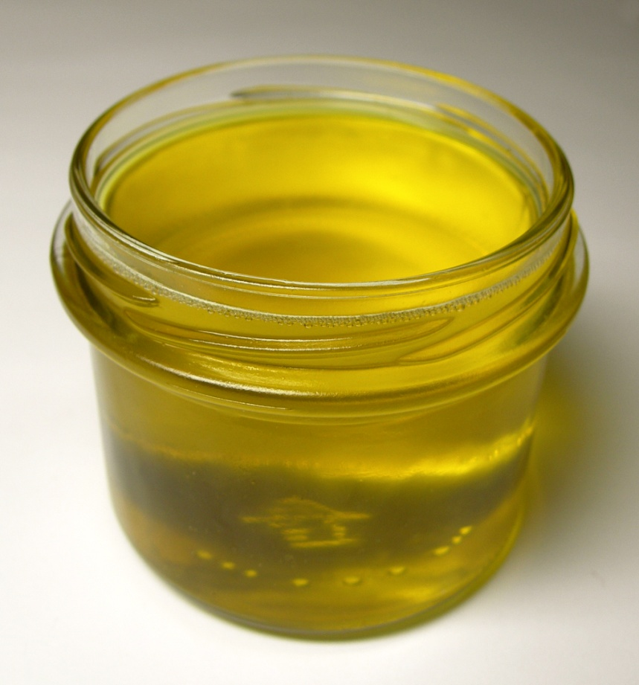

Fig 1.02 Rice bran oil.

Table 1.1 Properties of rice bran oil

|  |  |
| --- | --- |
| PROPERTY | RICE BRAN OIL |
| Density (kg/m3) | 906 |
| Kinematic viscosity (mm2/s at 40oC) | 38.2 |
| Flash point (oC) | 184.0 |
| Lower heating value (kJ/kg) | 40.85 |
| Cetane index | 51.02 |
| Free fatty acid (% oleic acid) | 0.12 |
| Acid value(mgKOH/g) | 0.06 |
| Pour point (oC) | 13 |
| Cloud point (oC) | 16 |
| pH value | 5.76 |

**2. LITERATURE REVIEW**

**Biodiesel production and properties, Amit Sarin**

The transesterification technique is used to minimize the viscosity and synthesize biodiesels. The technique is facilitated using catalysts including base homogenous and heterogeneous catalysts, acid homogenous and heterogeneous catalysts, acid–base heterogeneous catalysts and enzymes. The production of biodiesel using these catalysts with their advantages and disadvantages are analyzed elaborately. Other methods of biodiesel production like the BIOX co-solvent, non-catalytic supercritical alcohol, and catalytic supercritical methanol methods, as well as ultrasound and radio-frequency-assisted and in situ biodiesel synthesis are discussed critically in detail. How biodiesel is purified and the influence of the different parameters on production, the molar ratio of alcohol to oil, the reaction temperature, water and free fatty acid contents, catalyst concentration and reaction time are discussed. The major advantages of biodiesel are also reported.

Dependence of other properties of biodiesel on fatty acid methyl ester composition and other factors highlights the various prediction models for the properties of biodiesel like the viscosity, sulfur content, flash point, cetane number, carbon residue content, distillation temperature, water, free glycerol, contamination, glycerides, higher heating value, iodine value and density.

Diesel engine efficiency and emissions using biodiesel and its blends, the influence of biodiesel with other factors such as additives, on diesel engine performance and combustion and emission characteristics are discussed. Durability tests of diesel engines operated using biodiesel and its blends are also discussed. Statistical relationships between biodiesel performance and emission characteristics and fatty acid methyl ester composition are also discussed.

Major resources for biodiesel production, the possibilities of various feed stocks for biodiesel production with their detailed analyses are discussed. Other potential resources for biodiesel production are also discussed.

Present state and policies of the biodiesel industry, highlights the present state and policies of the biodiesel industries in the EU, the USA, India and various other countries.

The production of biofuels from edible oils has raised concerns over preserving food security. The food versus fuel issue and the possible solutions regarding this issue are discussed.

**Zullaikah et al**. had successfully obtained biodiesel from rice bran oil with high free fatty acids content. A two-step acid-catalyzed methanolysis process was employed for the efficient conversion of rice bran oil into fatty acid methyl esters.

**Gerhard Vellguth et al.** studied the performance of a direct injection single cylinder diesel engine with different vegetable oils. He reported that vegetable oils could be directly used as fuels in diesel engines on a short-term basis with little loss in efficiency. In long-term operation of engine with vegetable oils, he observed operational difficulties like carbon deposits, changes in the lubricating oil properties and ring sticking problems.

**Agarwal et al.** evaluated the performance and emission characteristics of linseed oil, mahua oil and rice bran oil blends. It was reported that linseed oil blends showed comparable thermal efficiency at lower loads; 50% linseed oil blends were found to be more efficient than other blends. Smoke density was higher for 50% blends compared to all other linseed oil blends. Smoke density was found to be higher for mahua blends as compared to mineral diesel at lower engine loads. Rice bran oil blends showed comparable thermal efficiency to that of diesel fuel. 20% rice bran oil blend showed minimum brake specific energy consumption and improved performance.

**Al-Widyan et al.** have carried out variable speed tests on a single cylinder direct injection diesel engine using different blends of biodiesel in diesel, produced from waste vegetable oil. The comparison of the biodiesel blends and the diesel fuel operation was done in terms of engine performance and exhaust emissions. It was found that with biodiesel blends, the engine operated smoothly without significant problems. The blends burnt more efficiently with better fuel economy and further generated lower emissions.

SUMMARY OF LITERATURE SURVEY

The literature review suggests that the vegetable oils have high energy content and reasonably good fuel properties, but they require processing to biodiesel for its safe use in compression ignition engines. It is reported that because of high viscosity, the neat vegetable oils can lead to thickening in cold climate, fuel flow problems, poor atomization and low efficiency. The vegetable oils therefore need to be converted into biodiesel, which has properties suitable for application in diesel engines**.** The available literature shows that the transesterification process has been a most suitable and acceptable method for biodiesel production. From the experiments and studies conducted by plenty of scientists and researchers, it has been observed that the biodiesel mostly causes reduction in engine power and torque, but some studies have reported higher engine power than conventional diesel fuel. Most of the studies showed lower carbon dioxide, carbon monoxide, hydrocarbons and smoke emissions with the biodiesel as compared to mineral diesel with a slight increased in NOX emissions.

Although encouraging work has been carried out on performance, emissions and combustion of biodiesel produced from vegetable oils like jatropha oil, karanja oil, sunflower oil, soya oil etc., but it was observed from literature survey that limited amount of work has been done to evaluate performance, emission characteristics and combustion analysis of diesel engine with biodiesel produced from non-traditional vegetable oils like thumba oil, neem oil etc. The prospect for vegetable oils and biodiesel is very promising in the short term because of their availability and suitability as a diesel engine fuel.

**3. PHASES OF THE PROJECT**

* Acid test experiments on various vegetable oils.
* Analysis of rice bran oil (GC-MS Test).
* Synthesis of biodiesel from rice bran oil.
* Experimental optimization of catalyst concentration for maximum yield.
* Theoretical prediction of biodiesel yield by using “MINITAB 17”.
* Analysis of compounds in synthesised biodiesel (GC-MS Test).
* Performance analysis on CI engine using diesel, B5, B10, and B20 blends.

3.1 ACID TEST EXPERIMENT

Biodiesel synthesis is possible only if the percentage free fatty acid of oil is less than 3%.

Percentage free fatty acid = 0.5*(acid value).

PROCEDURE FOR ACID TEST

* Take two beakers.
* Fill each beaker with 125ml of solvent. (Solvent is 50% of Isopropanol and 50% of Toluene).
* Add 5g of oil to one of the beakers.
* Add 2ml of phenolphthalein indicator to both beakers.
* The solution without oil is blank solution.
* Titrate both beakers with 0.1N KOH to the appearance of first permanent pink colour.

$ACID VALUE=\frac{\left(A-B\right)*N*56.1}{W}$

Where

A = number of ml of KOH to neutralize sample solution.

B = number of ml of KOH to neutralize blank solution.

N = normality of KOH solution (0.1 in this case).

W = weight of sample in grams.

We conducted acid test on cashew nut shell oil, rice bran oil, coconut oil and sun flower oil.

ACID TEST RESULTS:

Table 3.1 Acid test result

|  |  |
| --- | --- |
| OIL | %FFA |
| Cashew nut shell oil | 392.58 |
| Rice bran oil | 2.244 |
| Coconut oil | 0.8415 |
| Sunflower oil | 0.42075 |

3.2 ANALYSIS OF RICE BRAN OIL (GC-MS TEST).

The GC-MS is composed of two major building blocks: the [gas chromatograph](https://en.wikipedia.org/wiki/Gas_chromatograph) and the [mass spectrometer](https://en.wikipedia.org/wiki/Mass_spectrometer). The gas chromatograph utilizes a capillary column which depends on the column's dimensions (length, diameter, film thickness) as well as the phase properties (e.g. 5% phenyl polysiloxane). The difference in the chemical properties between different [molecules](https://en.wikipedia.org/wiki/Molecule) in a mixture and their relative affinity for the stationary phase of the column will promote separation of the molecules as the sample travels the length of the column. The molecules are retained by the column and then elute (come off) from the column at different times (called the retention time), and this allows the mass spectrometer downstream to capture, ionize, accelerate, deflect, and detect the ionized molecules separately. The mass spectrometer does this by breaking each molecule into [ionized](https://en.wikipedia.org/wiki/Ion) fragments and detecting these fragments using their mass-to-charge ratio.

Rice bran oil sample sourced from small scale rice millers was send for GC-MS test and the result of the test specified the constituents of the oil.

COMPOUNDS IN RICE BRAN OIL:

* n-Hexadecanoic acid
* 9,12- Octadecanoic acid
* 2-Methyl-7-Nonadecene
* Propanamide, 3-Bromo-N-(4-Bromo-2Chlorophenyl)

tic.wmf

Fig 3.01 GC-MS test result of rice bran oil

3.3 SYNTHESIS OF BIODIESEL FROM RICE BRAN OIL

**OIL + ALCOHOL → BIODIESEL + GLYCEROL**

(CATALYST: KOH)

OIL : Rice bran oil.

ALCOHOL : Methanol.

CATALYST : KOH.

EQUIPMENT : Magnetic stirrer with hot plate.

TEMPERATURE : 60°C

PROCEDURE

* Measure 150 ml of rice bran oil in a beaker.
* Measure 30 ml of methanol in a beaker (oil : methanol = 1:6)
* Measure 1.365 g of KOH (1% weight of oil) and dissolve it completely in methanol.
* Preheat the oil using magnetic stirrer with hot plate.
* Adjust the temperature to 60 degree Celsius.
* Add the solution of KOH and methanol to the oil.
* Leave the mixture stirring at constant speed and temperature for one hour.
* Then transfer the mixture to the separating funnel.
* Keep the mixture in the separating funnel for 24 hours, then biodiesel and glycerol gets separated into two layers.
* Remove the glycerol from separating funnel.
* Wash the biodiesel with warm water and keep it again for separation in the separating funnel to remove the dissolved impurities.
* Wash it 2-3 times till pure biodiesel is obtained.
* Heat the biodiesel.

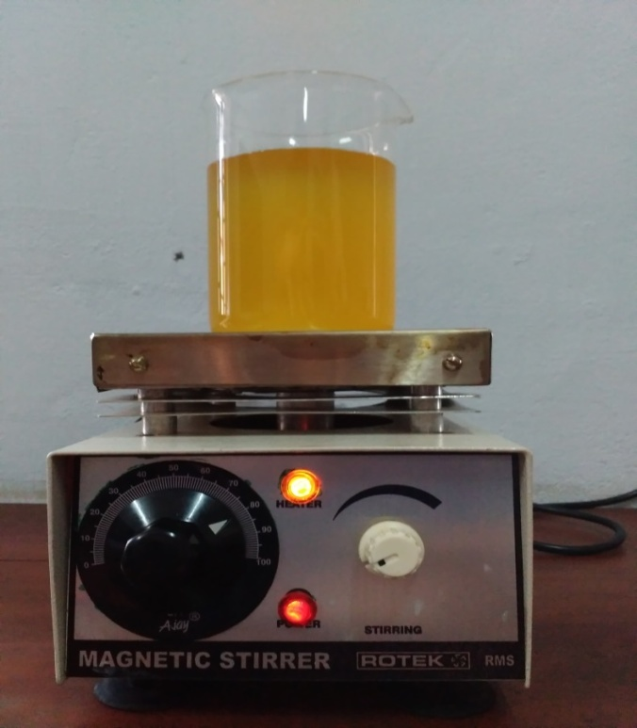

Fig. 3.02 Magnetic stirrer with hot plate

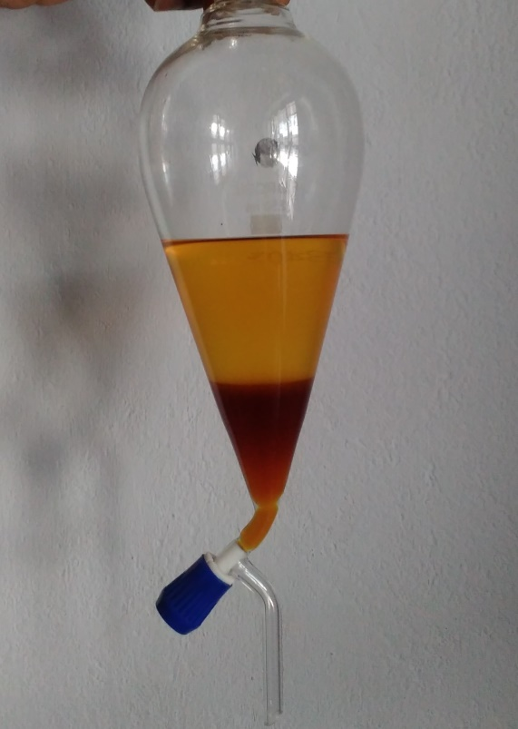

Fig 3.03 Layer of impure biodiesel over settled glycerol.

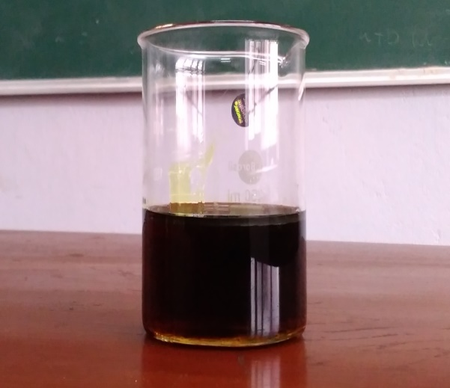

Fig 3.04 Glycerol

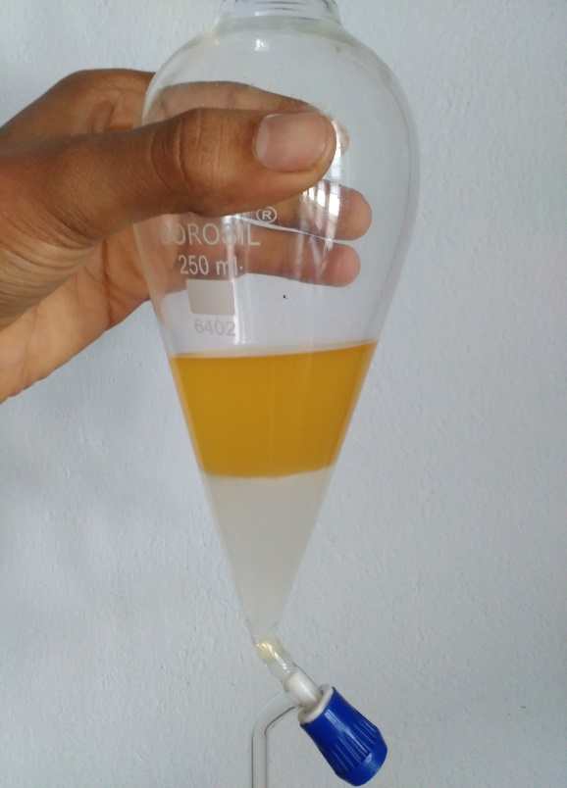

Fig 3.05 Pure biodiesel over impurities after washing.

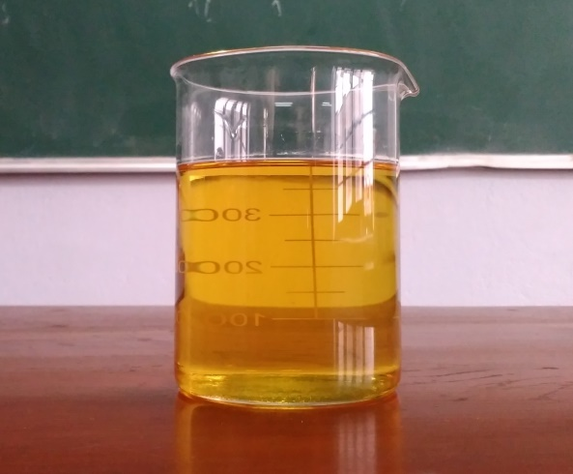

Fig 3.06 Biodiesel

3.4 EXPERIMENTAL OPTIMIZATION

Various samples of Biodiesel were synthesized by varying the catalyst concentration and the optimum catalyst concentration for maximum yield was identified.

Table 3.2 Experimental results

|  |  |  |
| --- | --- | --- |
| METHANOL(% wt. of oil) | KOH(% wt. of oil) | BIODIESEL YIELD(%) |
| 19.8 | 0.25 | 40 |
| 19.8 | 0.50 | 46.5 |
| 19.8 | 0.75 | 53 |
| 19.8 | 0.90 | 70 |
| 19.8 | 1.00 | 83 |
| 19.8 | 1.25 | 82 |
| 19.8 | 1.50 | 80 |

Fig 3.07 Biodiesel yield v/s KOH concentration

3.5 THEORETICAL PREDICTION

MINITAB17

Minitab, originally intended as a tool for teaching statistics, is a general-purpose statistical software package designed for easy interactive use. Minitab is well suited for instructional applications, but is also powerful enough to be used as a primary tool for analyzing research data.

From the above experimental results a formula for biodiesel yield with KOH concentration as variable is generated using the software “MINITAB17”.

THE EQUATION IS:

BIODIESEL YIELD (%) = 31.06 + 38.55 KOH (%)

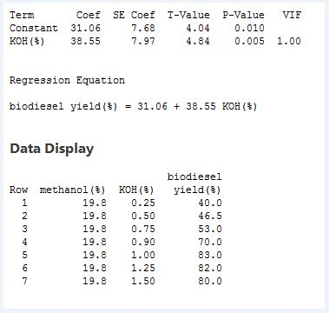

Fig 3.08 Equation for biodiesel yield

3.6 ANALYSIS OF BIODIESEL

GAS CHROMATOGRAPHY-MASS SPECTROSCOPY TEST

The sample of the synthesized biodiesel was send for GC-MS test and the result of the test specified the constituents of the rice bran oil biodiesel.

COMPOUNDS IN RICE BRAN OIL BIODIESEL:

* Hexadecanoic acid methyl ester
* 9,12-Octadecanoic acid methyl ester
* 9-Octadecanoic acid methyl ester
* 11-Eicosenoic acid methyl ester
* Eicosenoic acid methyl ester
* Docosanoic acid methyl ester
* Tetracosanoic acid methyl ester
* Methyl tetradecanoate
* Methyl hexadec-9-enoate
* Methyl stearate

tic.wmf

Fig 3.09 GC-MS test result of rice bran oil biodiesel.

COMPARISON OF GC-MS TEST RESULTS

Table 3.3 GC-MS test result comparison

|  |  |
| --- | --- |
| COMPOUNDS IN OIL | COMPOUNDS IN BIODIESEL |
| n-Hexadecanoic acid | Hexadecanoic acid methyl ester |
| 9,12- Octadecanoic acid | 9,12-Octadecanoic acid methyl ester |
| 2-Methyl-7-Nonadecene | 9-Octadecanoic acid methyl ester |
| Propanamide, 3-Bromo-N-(4-Bromo-2Chlorophenyl) | 11-Eicosenoic acid methyl ester |
|  | Eicosenoic acid methyl ester |
|  | Docosanoic acid methyl ester |
|  | Tetracosanoic acid methyl ester |
|  | Methyl tetradecanoate |
|  | Methyl hexadec-9-enoate |
|  | Methyl stearate |

GC-MS TEST results shows that, all the compounds in the oil has converted into its corresponding methyl esters, which means, the oil has undergone transesterification and has become biodiesel.

PROPERTY COMPARISON OF RICE BRAN OIL AND RICE BRAN BIODIESEL

Table 3.4 Property comparison

|  |  |  |
| --- | --- | --- |
| Property | Rice bran oil | Biodiesel |
| Density (kg/m³) | 906 | 885 |
| Kinematic viscosity(mm²/s at 40°C) | 38.2 | 4.54 |
| Calorific value (MJ/kg) | 40.85 | 41.60 |
| Acid value (mgKOH/g) | 0.06 | 0.08 |

3.6 TESTING

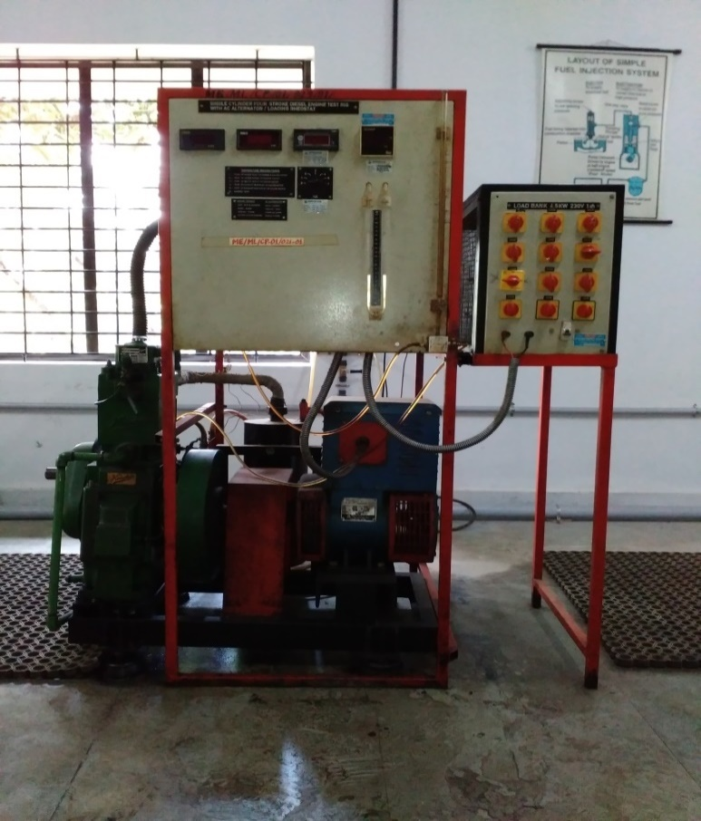

Fig 3.10 Four stroke single cylinder diesel engine

Performance test was conducted on four stroke single cylinder diesel engine and the following results were obtained.

Table 3.5 Observation table for B5

|  |  |  |  |  |  |  |  |  |  |  |
| --- | --- | --- | --- | --- | --- | --- | --- | --- | --- | --- |
| N | B.P | TFC | SFC | IP | Qact | Qth | ηbther | ηither | ηm | ηv |
| rpm | watts | kg/hr | kg/Whr | W | m³/min | m³/min | % | % | % | % |
| 1600 | 0 | 0.3579 | - | 1360 | 0.3891 | 0.4423 | 0 | 31.80 | 0 | 87.96 |
| 1577 | 532.22 | 0.4532 | 0.000852 | 1892.22 | 0.3891 | 0.4359 | 9.83 | 34.95 | 28.12 | 89.25 |
| 1570 | 1024.22 | 0.5555 | 0.000542 | 2384.22 | 0.3891 | 0.4340 | 15.43 | 35.92 | 42.95 | 89.64 |
| 1554 | 1501.2 | 0.6616 | 0.000441 | 2861.2 | 0.3806 | 0.4296 | 18.99 | 36.20 | 52.46 | 88.61 |
| 1539 | 1999.8 | 0.7879 | 0.000394 | 3359.8 | 0.3778 | 0.4254 | 21.24 | 35.69 | 59.52 | 88.80 |
| 1529 | 2480.12 | 0.9283 | 0.000374 | 3840.12 | 0.3749 | 0.4227 | 22.36 | 34.63 | 64.58 | 88.70 |

Table 3.6 Observation table for B10

|  |  |  |  |  |  |  |  |  |  |  |
| --- | --- | --- | --- | --- | --- | --- | --- | --- | --- | --- |
| N | B.P | TFC | SFC | IP | Qact | Qth | ηbther | ηither | ηm | ηv |
| rpm | watts | kg/hr | kg/Whr | W | m³/min | m³/min | % | % | % | % |
| 1587 | 0 | 0.3367 | - | 1620 | 0.3891 | 0.4387 | 0 | 40.28 | 0 | 88.68 |
| 1576 | 526.68 | 0.4557 | 0.000865 | 2146.68 | 0.3863 | 0.4357 | 9.67 | 39.43 | 24.53 | 88.66 |
| 1570 | 1024.22 | 0.5436 | 0.000531 | 2644.22 | 0.3835 | 0.4340 | 15.77 | 40.72 | 38.73 | 88.35 |
| 1555 | 1494.52 | 0.6508 | 0.000436 | 3114.52 | 0.3835 | 0.4298 | 19.22 | 40.06 | 47.98 | 89.21 |
| 1540 | 1971.32 | 0.7735 | 0.000392 | 3591.32 | 0.3778 | 0.4257 | 21.33 | 38.86 | 54.89 | 88.74 |
| 1527 | 2422.16 | 0.9114 | 0.000376 | 4042.16 | 0.3749 | 0.4221 | 22.24 | 37.12 | 59.92 | 88.82 |

Table 3.7 Observation table for B20

|  |  |  |  |  |  |  |  |  |  |  |
| --- | --- | --- | --- | --- | --- | --- | --- | --- | --- | --- |
| N | B.P | TFC | SFC | IP | Qact | Qth | ηbther | ηither | ηm | ηv |
| rpm | watts | kg/hr | kg/Whr | W | m³/min | m³/min | % | % | % | % |
| 1589 | 0 | 0.3322 | - | 1540 | 0.3918 | 0.4392 | 0 | 38.80 | 0 | 89.20 |
| 1580 | 520.72 | 0.4410 | 0.000847 | 2060.72 | 0.3863 | 0.4368 | 9.88 | 39.11 | 25.26 | 88.44 |
| 1570 | 1005.24 | 0.5409 | 0.000538 | 2545.24 | 0.3863 | 0.4340 | 15.55 | 39.38 | 39.49 | 89.00 |
| 1557 | 1483.77 | 0.6527 | 0.00044 | 3023.77 | 0.3835 | 0.4304 | 19.03 | 38.78 | 49.07 | 89.09 |
| 1540 | 1974.78 | 0.7815 | 0.000396 | 3514.78 | 0.3806 | 0.4257 | 21.15 | 37.64 | 56.18 | 89.41 |
| 1526 | 2409.78 | 0.9183 | 0.000381 | 3949.78 | 0.3778 | 0.4218 | 21.96 | 36.00 | 61.01 | 89.56 |

Table 3.8 Observation table for Diesel

|  |  |  |  |  |  |  |  |  |  |  |
| --- | --- | --- | --- | --- | --- | --- | --- | --- | --- | --- |
| N | B.P | TFC | SFC | IP | Qact | Qth | ηbther | ηither | ηm | ηv |
| rpm | watts | kg/hr | kg/Whr | W | m³/min | m³/min | % | % | % | % |
| 1585 | 0 | 0.3195 | - | 1580 | 0.3918 | 0.4381 | 0 | 41.39 | 0 | 89.43 |
| 1569 | 535.92 | 0.4213 | 0.000786 | 2115.92 | 0.3918 | 0.4337 | 10.64 | 42.03 | 25.32 | 90.34 |
| 1557 | 1010.67 | 0.5142 | 0.000509 | 2590.67 | 0.3891 | 0.4304 | 16.45 | 42.17 | 39.01 | 90.39 |
| 1540 | 1484.28 | 0.6237 | 0.00042 | 3064.28 | 0.3863 | 0.4257 | 19.92 | 41.12 | 48.43 | 90.74 |
| 1527 | 1969.53 | 0.7544 | 0.000383 | 3549.53 | 0.3835 | 0.4221 | 21.85 | 39.38 | 55.48 | 90.84 |
| 1511 | 2422.16 | 0.8730 | 0.00036 | 4002.16 | 0.3778 | 0.4177 | 23.22 | 38.37 | 60.52 | 90.44 |

Fig 3.11 Variation of mechanical efficiency with brake power

Fig 3.12 Variation of brake thermal efficiency with brake power

Fig 3.13 Variation of specific fuel consumption with brake power

Fig 3.14 Variation of volumetric efficiency with brake power

**4. ADVANTAGES**

REDUCES HARMFUL EMISSIONS AND POLLUTANTS:

Biodiesel fuels reduce emissions of various pollutants and global warming gases such as CO, CO2, hydrocarbons and particulate matter by as much as 50% compared to conventional diesel. Because biodiesel fuels can substantially reduce “air toxics” such as particulate matter and hydrocarbon emissions that have been proven to cause cancer and other life threatening illnesses, significant health benefits are also realized via biodiesel superior emissions profile. The higher the percentage contents of biodiesel, i.e. using B20 instead of B5 fuels, the greater the reduction in harmful emissions and pollutants.

SAFE:

Biodiesel contains no hazardous materials and is regarded as safe to use. A number of studies have found that biodiesel biodegrades much more rapidly than convention diesel and thus is being increasingly used in environmentally sensitive areas such as wetlands, marine environments and national parks.

EASY TO USE:

Biodiesel is a “drop in” technology for fuel blends of B20 or less. No new equipment or engine modifications are necessary. B2 to B20 blends can be stored in existing diesel fuel tanks and pumped with current diesel equipment.

IMPROVES LUBRICITY:

Low lubricity diesel fuel may cause high wear and scarring, whereas high lubricity fuel may provide reduced wear and longer component life. Biodiesel fuel blends offer significantly higher lubricity than conventional diesel. This may be particularly important since nearly all diesel fuel is now Ultra Low Sulfur Diesel that has poor lubricating qualities.

DECREASES DEPENDENCY ON FOREIGN PETROLEUM PRODUCTS:

Biodiesel fuels extend our national petroleum supplies and reduce our reliance on imported oil.

**5. LIMITATIONS**

TECHNICAL CHALLENGES:

Perhaps the most straightforward of biofuel's drawbacks is the most obvious: It isn't petroleum-based fuel, so it will operate differently in [engines](http://auto.howstuffworks.com/engine.htm) designed for petroleum-based fuel. Biodiesel has a higher density than diesel; fuel injectors have to be larger to match the fuel flow of a comparable diesel engine. And biodiesel can corrode or damage some of the metal and rubber fittings used in diesel-powered engines. The conversion from one fuel to the other, in some cases, requires a range of new injectors, gaskets and fuel lines.

HIGH COST OF PRODUCTION:

Even with all the benefits associated with biofuels, they are quite expensive to produce in the current market. As of now, the interest and capital investment being put into biofuel production is fairly low but it can match demand. If the demand increases, then increasing the supply will be a long term operation, which will be quite expensive. Such a disadvantage is still preventing the use of biofuels from becoming more popular.

MONOCULTURE:

Monoculture refers to practice of producing same crops year after year, rather than producing various crops through a farmer’s fields over time. While, this might be economically attractive for farmers but growing same crop every year may deprive the soil of nutrients that are put back into the soil through crop rotation.

USE OF FERTILIZERS:

Biofuels are produced from crops and these crops need fertilizers to grow better. The downside of using fertilizers is that they can have harmful effects on surrounding environment and may cause water pollution. Fertilizers contain nitrogen and phosphorus. They can be washed away from soil to nearby lake, river or pond.

INDUSTRIAL POLLUTION:

The carbon footprint of biofuels is less than the traditional forms of fuel when burnt. However, the process with which they are produced makes up for that. Production is largely dependent on lots of water and oil. Large scale industries meant for churning out biofuel are known to emit large amounts of emissions and cause small scale water pollution as well. Unless more efficient means of production are put into place, the overall carbon emission does not get a very big dent in it.

WATER USE:

Large quantities of water are required to irrigate the biofuel crops and it may impose strain on local and regional water resources, if not managed wisely. In order to produce corn based ethanol to meet local demand for biofuels, massive quantities of water are used that could put unsustainable pressure on local water resources.

**6. CONCLUSION**

The results of the investigations carried out in this project work are briefly summarized below

* Acid test was conducted on sunflower oil, rice bran oil, coconut oil and cashew nut shell oil.
* Biodiesel was synthesized from rice bran oil using transesterification process. The process was done using methanol as reagent and potassium hydroxide as catalyst.
* The yield of biodiesel was experimentally found for various catalyst concentrations. The optimum yield was found to be 83% for 1% (weight percentage of rice bran oil) KOH concentration.
* A relation was formed between KOH concentration and biodiesel yield using MINITAB 17 software. The equation is: BIODIESEL YIELD (%) = 31.06 + 38.55 KOH (%)
* GC-MS test was conducted on both rice bran oil and biodiesel prepared from it.
* The performance test was conducted in four stroke single cylinder diesel engine using blends of biodiesel B5, B10, B20 and commercial diesel as fuel. The mechanical efficiency of B5 edged out from others. The brake thermal efficiency was almost same for B5, B10, B20 but falls short of commercial diesel. The SFC was found to be least for diesel compared to other fuel. The volumetric efficiency showed complex pattern. Commercial diesel was found to have highest volumetric efficiency.

From the project we could conclude that biodiesel blend with commercial diesel could replace the existing diesel engine without any hardware modifications. It can also be concluded that the biodiesel reduces the environmental impacts of transportation and reduce the dependence on crude oil imports. Since physical properties of biodiesel are close to those of diesel fuel it can be one of the right solutions for the energy scenario of India.

**REFERENCES**

[1] BhabaniPrasanna Pattanaik, Basanta Kumar Nanda and Probir Kumar Bose, “Performance & emission studies on a single Cylinder DI diesel engine fueled with diesel & Rice bran oil methyl ester blends”, March 2012 ISSN: 2231-1963

[2] Rao PS, Gopalkrishnan KV. “Vegetable oils and their methyl esters as fuel in diesel engines”. Indian J Technol 1991; 29:292–7.

[3] Nwafor OMI. “Emission characteristics of diesel engine operating on rapeseed methyl ester”. Renewable Energy 2004;29(1):119–29.

[4] Lapuerta M, Armas O, Rodriguez FJ. “Effect of bio-diesel fuels on diesel engine emissions” . Energy Sci 2008:198–223.

[5]Amit Sarin, “Biodiesel production and properties”.

[6] Zullaikah et al., “A two step acid catalyzed process for the production of biodiesel from rice bran oil”.

[7] Gerhard Vellguth et al., “effect of injection timing on performance and emission characteristics of four stroke single cylinder DI diesel engine using PME blend as fuel”.

[8]Agarwal et al., “performance evaluation of vegetable oil fueled compression ignition engine”.

[9] Al-Widyan et al., “combustion performance and emission of ethyl ester of a waste vegetable oil in a water cooled furnace”.

[10] Fangrui Ma, Milford A. “Biodiesel production review”. Bioresour technol 1999

[11] Li, C.Z.; Jiang, L.J; Cheng, S.Q. (2005) Green energy resources- Biodiesel; Chemical Industrial Press: Beijing, China.